Methodological Detail Appendix (MDA)

Boundaries of Constructive Choice: On the Accessibility of Maximize Accuracy and Minimize Effort Goals

FELIPE M. AFFONSO
CHRIS JANISZEWSKI
JAMES R. BETTMAN

APPENDIX A: SEQUENTIAL SEARCH TRAINING TASK 5
APPENDIX B: DECISION PROCESS GOALS MANIPULATIONS 9
APPENDIX C: DECISION DIFFICULTY MANIPULATIONS 10
Conflicting and Complementary Benefit Goals Manipulations (Experiments 1, 2, 3a, 3b, 4a, and 4b) 10
Prestige Benefit Goal (Experiments 1, 2, 3a, 3b, 4a, and 4b) 10
Thrift Benefit Goal (Experiments 1, 3a, and 3b) 10
Have Fun Benefit Goal (Experiments 2, 4a, and 4b) 11
APPENDIX D: REPLICATE OPTIONS AND DIFFICULTY MANIPULATIONS OF EXPERIMENTS 5 AND 6 12
Experiments 1, 2, 3a, 3b, 4a, and 4b: Vacation Package Options 13
Experiments 1, 2, 3a, 3b, 4a, and 4b: Car Options 16
Experiment 5: Movie Options (Easy Condition) 19
Experiment 5: Movie Options (Moderate Condition) 26
Experiment 5: Movie Options (Difficult Condition) 33
Experiment 6: Laptop Options (Easy Condition) 47
Experiment 6: Laptop Options (Difficult Condition) 50
APPENDIX E: ADDITIONAL DETAILS ABOUT THE SEQUENTIAL SEARCH PROCEDURE 53
APPENDIX F: ADDITIONAL METHODOLOGICAL DETAILS AND ANALYSES FOR EXPERIMENT 1 68
Benefit Goals Pretests 68
Benefit Goals Pretests – Vacation Packages. 68
Benefit Goals Pretests – Cars. 70
Manipulation Check 72
Decision Process Goals 72
Decision Difficulty. 72
Choice Shares 73
Product Replicate Analyses 75
Product Replicates (number of options considered). 75
Product Replicate Position (number of options considered). 75
Product Replicates (choice of best option considered). 75
Product Replicate Position (choice of best option considered). 75
Product Replicates (satisficing/choice of last option considered). 76
Product Replicate Position (satisficing/choice of last option considered). 76
Time Measures 76
APPENDIX G: METHODOLOGICAL DETAILS AND ADDITIONAL analyses for experiment 2 78
Manipulation Check 78
Decision Process Goals 78
Decision Difficulty. 78
Choice Shares 78
Product Replicate Analyses 80
Product Replicates (number of options considered). 80
Product Replicate Position (number of options considered) 80
Product Replicates (choice of best option considered) 81
Product Replicate Position (choice of best option considered). 82
Product Replicates (satisficing/choice of last option considered). 82
Product Replicate Position (satisficing/choice of last option considered). 82
Time Measures 82
APPENDIX H: METHODOLOGICAL DETAILS AND ADDITIONAL ANALYSES FOR EXPERIMENTS 3A AND 3B 84
Manipulation Check 84
Decision Difficulty (3a) 84
Decision Difficulty (3b) 84
Product Replicates (3a) 85
Product Replicates (3b) 85
Alternative Explanations 85
Measures 85
Alternative Explanations (3a) 86
Alternative Explanations (3b) 86
APPENDIX I: METHODOLOGICAL DETAILS AND ADDITIONAL ANALYSES FOR EXPERIMENTS 4A AND 4B 88
Manipulation Check 88
Decision Ease (4a). 88
Decision Ease (4b) 88
Product Replicate Analyses 89
Product Replicates (4a) 89
Product Replicates (4b) 89
Alternative Explanations 90
Measures 90
Alternative Explanations (4a) 90
Alternative Explanations (4b) 90
APPENDIX J: METHODOLOGICAL DETAILS AND ADDITIONAL ANALYSES FOR EXPERIMENT 5 92
Manipulation Check 92
Decision Process Goal (maximize accuracy) 92
Decision Process Goal (minimize effort) 92
Decision Difficulty 93
Process Goal Abandonment 93
Choice Shares 95
Time Measures 97
APPENDIX K: METHODOLOGICAL DETAILS AND ADDITIONAL ANALYSES FOR EXPERIMENT 6 99
Process Goal Accessibility Prime Manipulations 99
8 Options – Effort/Accuracy Trade-Off Not Salient 99
50 Options – Effort/Accuracy Trade-Off Salient 99
Stimuli for Process Goal Accessibility Prime Manipulations 99
Manipulation Check 102
Decision Difficulty 102
Decision Process Goal (maximize accuracy) 102
Decision Process Goal (minimize effort) 103
Effort-Accuracy Trade-Off Focus 104
Process Goal Abandonment. 104
Choice Shares 106
Time Measures 107
APPENDIX L: MEANS AND STANDARD DEVIATIONS 108
APPENDIX m: data collection plan and exclusions 110
REFERENCES 113

APPENDIX A: SEQUENTIAL SEARCH TRAINING TASK
In this study, we are interested in understanding how people make choices. Later in this survey, we will ask you to investigate different [product category – vacation packages and cars, movies, or laptops, depending on the study], and choose one of the options. However, you will first be told about how to make a choice in this survey. On the next pages, there will be a tutorial showing you how you do your choice. After this tutorial, you will proceed to the first study of our survey. Click the arrow button to continue.
Page break

You will see three different possible choices: option A, option B, and a choice to look to another option (the option C). This will happen successively (you can decide to see a fourth (D), a fifth (E), a sixth (F), and several other options, if you want to).
If you want any of the options that are displayed, just select your preferred option and click the Arrow button. If you want to see more options other than the ones that are displayed, click "Look at another option before deciding". The additional option will appear automatically. This pattern will be the same later in the survey.
You can choose to look to as many options as you want. You can also select an option at any point, including as your first choice. There are several options, but you do NOT have to look at all of them. Click the arrow button to proceed to the tutorial. After finishing the tutorial, you will be directed to the next part of this survey.
Page break
Tutorial
- Option B | - Option A
- Look at another option before deciding
Page break

If the participant chooses to “Look at another option before deciding”, the additional option is randomly drawn (without replacement) from the pool of options. The additional option is always positioned as the first option in the choice matrix. The order of previously seen options is maintained.

Tutorial
- Option C | - Option B |  | - Option A
- Look at another option before deciding

Page break

If the participant chooses to “Look at another option before deciding” again:

Tutorial
- Option D | - Option B |  | - Option A
- Option C
- Look at another option before deciding

Page break

If the participant keeps choosing to “Look at another option before deciding” until all the available options are displayed:

Tutorial
- Option O | - Option J | - Option E
- Option N | - Option I | - Option D
- Option M | - Option H | - Option C
- Option L | - Option G | - Option B
- Option K | - Option F | - Option A
- All the available options are displayed. Please select one of the options above.

In all the choice tasks, except when noted, the options are displayed in a 3-column matrix (except for the first page, which has only two options/columns). The number of rows depends on how many options are displayed to participants.
The “additional option” that keeps appearing each time the participant clicks “Look at another option” always is placed on the 1st row, 1st column. The remaining options (that are carried over) are always positioned “from last to first” in a column-major array order, and their position depends on the order of appearance. To exemplify: the most recent option always appears on the 1st row and 1st column. The second most recent option appears below (2nd row, 1st column). The third most recent option appears below (3rd row, 1st column). Depending on the number of options that is being displayed, the subsequent option is positioned in the 1st row, 2nd column. This is referred to as “column-major order” array representation. Please see the illustration below.
Option O is the latest option that appeared (i.e., the most recent option). Option A is one of the first options that appeared. In a sequential search setting (as in our studies), the order of options, as they appeared, would be A, B, C, D, E, …, O.
We provide more details on programming this type of task on Qualtrics on methodological detail appendix E (the additional information about the sequential search task appendix).

- Option O | - Option J | - Option E
- Option N | - Option I | - Option D
- Option M | - Option H | - Option C
- Option L | - Option G | - Option B
- Option K | - Option F | - Option A

If the participant chooses any of the options at any point:

Since you selected one of the options, you finished the sequential search training task. Please click the Arrow button to proceed to the next part of this survey.

APPENDIX B: DECISION PROCESS GOALS MANIPULATIONS
Participants first read the following: “When people make a choice, they make an effort-accuracy-tradeoff. Some people want to put in less effort because they simply want to get the choice done. Some people want to put in more effort because they want to be accurate.”
Participants in the maximize accuracy process goal condition read:
“In this study, we are interested in learning why people want to be accurate when they make choices. Please list three reasons why you would want to be accurate when you make a choice. Examples of other people's responses are... (1) because I want to get something I really like; (2) because I want to make sure I get the best possible option.”

Participants in the minimize effort process goal condition read:
“In this study, we are interested in learning why people want to put in less effort when they make choices. Please list three reasons why you would want to put in less effort when you make a choice. Examples of other people's responses are: (1) because I simply want to get the choice done without wasting my time; (2) because I want to save energy for other activities.”

Participants in both conditions were given three boxes to list their reasons why they would want to act in a goal consistent manner. Reasons (Briley, Morris, & Simonson, 2000; Simonson & Nowlis, 2000) are commonly used to activate decision process goals. We also asked participants to consider the reasons they listed when making decisions in the survey.
Participants in the baseline decision process goal condition (i.e., no decision process goal) (experiments 5 and 6) simply read the following passage (along with an essay box):
“Life is full of experiences - ranging from regular things, such as commuting to work or purchasing certain products, to unusual or memorable things, such as traveling. Now, we are interested in learning about your purchase experiences. Please write about one purchase experience that recently happened to you. Write down in details what you remember from it. You will be able to proceed to the next page after 60 seconds, but we encourage you to write as much as you want.”

APPENDIX C: DECISION DIFFICULTY MANIPULATIONS

Conflicting and Complementary Benefit Goals Manipulations (Experiments 1, 2, 3a, 3b, 4a, and 4b)
Similar to some of the process goal manipulations, participants were given three boxes to list their reasons why they would want to act in a goal consistent manner. We also asked participants to consider these goals when making decisions in the survey. Participants in the decision difficulty – conflicting benefit goals conditions (experiments 1, 3a, and 3b) listed reasons (and were asked to consider) both prestige and thrift goals. Participants in the decision ease – complementary benefit goals conditions (experiments 2, 4a, and 4b) also listed reasons (and were asked to consider) both prestige and fun goals. Participants in the one-goal conditions (experiments 3a, 3b, 4a, and 4b) listed reasons for only one of the goals.

Prestige Benefit Goal (Experiments 1, 2, 3a, 3b, 4a, and 4b)
“Now, imagine that you have decided that having prestige should be a top priority in life. Being prestigious and pursuing status - when making simple or complex decisions - can significantly boost your self-esteem and reputation. Imagine that instead of worrying about how you are spending your money or worrying if you should stick to a particular budget, you will always try to focus on achieving a prestigious outcome. You will do this for current and future decisions. Please list three reasons why prestige would be important to you and how this would positively impact your life in the future. Examples of other people's responses are... (1) because I want to feel powerful and important. This makes me happier with myself; (2) you only live once. After all, money is meant to buy things. I want to be the best."

Thrift Benefit Goal (Experiments 1, 3a, and 3b)
“Now, imagine that you have decided that being thrifty should be a top priority in life. Being frugal and saving money - when making simple or complex decisions - can significantly boost your quality life and financial well-being. Imagine that instead of spending money on things you do not really need, or being extravagant, you will try to be thrifty. You will do this for current and future decisions. Please list three reasons why being thrifty would be important to you and how this would positively impact your life in the future. Examples of other people's responses are... (1) because I don't want to deal with overwhelming debt every month; (2) because I often buy things I don't really need, and I feel regret when looking at my budget."

Have Fun Benefit Goal (Experiments 2, 4a, and 4b)
“Now, imagine that you have decided that having fun should be a top priority in life. Having fun and embracing playfulness in your life - when making simple or complex decisions - can significantly boost your overall well-being and life satisfaction. Imagine that instead of taking things too seriously, and seeing the things you do as obligations, you will always try to focus on the fun of side of what you do. You will do this for current and future decisions. Please list three reasons why having fun would be important to you and how this would positively impact your life in the future. Examples of other people's responses are... (1) because I want to be happy in every single aspect of my life; (2) because seeing the fun side of life can make you enjoy things you usually don't feel like doing.”

The decision difficulty manipulations used in experiments 5 and 6 (amount of information and degree of inter-attribute correlation) were administered via the stimuli. Thus, we present them in the next section.

APPENDIX D: REPLICATE OPTIONS AND DIFFICULTY MANIPULATIONS OF EXPERIMENTS 5 AND 6
This methodological detail appendix shows the options that were used in all experiments. For additional information on the sequential search task, please see the methodological detail appendix E.
In this methodological detail appendix, we provide all options in a table format to facilitate the copy and paste of the text and figures (if needed). On Qualtrics, participants saw the options in a more aligned/organized way (each option was a choice in a multiple answer question – see MDA E for details). In addition, the fonts were slightly different in the actual survey. After the tables with the stimuli information, we also provide examples of the stimuli the way they were seen by the participants.

Experiments 1, 2, 3a, 3b, 4a, and 4b: Vacation Package Options
Fiji Hideaway Resort & Spa - 7 nights with flight $2861 (Coral Coast Area). Roundtrip airfare on Fiji Airways, 7 nights’ accommodation at Fiji Hideaway Resort & Spa in a Frangipani Bure.   | Hotel Palazzo Giovanelli & Gran Canal - 3 nights with flight $1732 (Venice, Italy). Reduced rate. Includes daily buffet breakfast.   | The Westin New York at Times Square - 3 nights with flight $883 $856 (Times Square). This plush hotel is set at the dazzling heart of New York, close to Broadway, museums and upscale shopping.  
Mauna Lani Bay Hotel & Bungalows - 3 nights with flight and car $1037 $876 (Kohala Coast, Hawaii). Discount, Ocean View, Includes EXCLUSIVE up to 5-Day FREE mid-size car rental.   | SAVOY - 4 nights with flight $1211 $876 (Rome) 27% OFF! 4th night FREE, Includes daily breakfast for ALL, Kids 7 & younger stay FREE.   | Blue Lagoon 7 Night Cruise - 7 nights with flight $3962 (Fiji). Lagoon Cruises in a Hibiscus Deck, all meals, cruise entertainment, shore excursions and activities included in the cruise schedule.  
Hyatt Zilara Cancun - 3 nights with flight $2882+ (Cancun, Mexico). Oceanfront Junior Suite, All-Inclusive: includes all meals, drinks, and activities.   | Beaches Turks & Caicos Resort Villages & Spa - 3 nights with flight $2702 (Turks & Caicos, Caribbean). Includes all meals, unlimited premium spirits & activities.   | The Confidante - By Hyatt - 3 nights with flight $384 (Miami Beach, Florida). Stays 5 nights or longer and receive Exclusive $100 Off per booking.  
Sheraton Buganvilias Resort & Convention Center - 3 nights with flight $409 (Puerto Vallarta, Mexico). Exclusive $100 Off per booking, Kids 12 & younger stay FREE, FREE Wi-Fi.   | Sheraton Puerto Rico Hotel & Casino - 3 nights with flight $539 $498 (Old San Juan, Puerto Rico). 20% off on Zen spa treatment, FREE Wi-Fi, Kids 17 & younger stay FREE.   | Mystique, A Luxury Collection Hotel - 3 nights with flight $2276 (Santorini, Greece). A one-of-a-kind experience on the iconic Greek island of Santorini.  
Walt Disney World Dolphin - 3 nights with flight $937 $707 (Disney). Cheap! Exclusive $50 Off per booking   | Flamingo Las Vegas - 3 nights with flight from $352 (Las Vegas). A self-contained casino and resort offering everything a vacationer could want.   | Hilton San Diego Bayfront - 3 nights with flight $466 (San Diego Bay Front, CA). Port/Coronado Bridge View, Stays of 5 nights or longer receive Exclusive $100 Off.  
Below, an example of a participant’s screen view displaying 6 options (with one selected option. Depending on the participant’s screen resolution, monitor size, and internet browser zoom level, there could be more or less options on the screen simultaneously. Participants could scroll down (and up) through the options. There were 3 columns (except for the first page, where participants only had two available options to choose from).


Experiments 1, 2, 3a, 3b, 4a, and 4b: Car Options
2012 Toyota Camry - XLE FWD - $11,500 (Used)  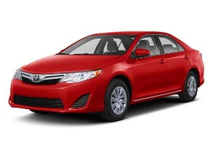 | 2017 Jaguar F-PACE S - AWD S 4dr SUV - $42,000 (New)  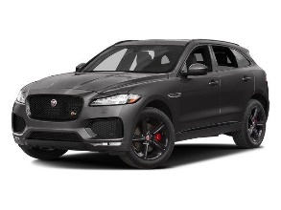 | 2017 Chevrolet Malibu LS - LS 4dr Sedan - $19,800 (New)  
2017 Subaru WRX STI Limited - AWD STI Limited 4dr Sedan - $31,700 $29,700 (New)  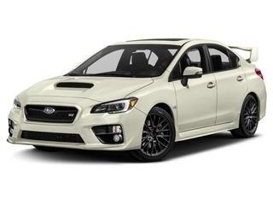 | 2008 Honda Accord LX - LX 4dr Sedan 5A - $9,575 $8,595 (Used)  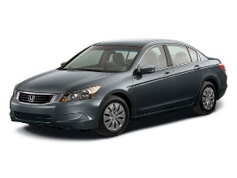 | 2017 Land Rover Range Rover Sport SVR - AWD SVR 4dr SUV - $89,989 $85,989 (New)  
2007 Ford Escape - XLS AWD 4dr SUV (2.3L I4 5M)​ - $5,420 $4,780 (Used)   | 2014 BMW 5 Series 550i xDrive - AWD 550i xDrive 4dr Sedan​ - $34,000 (Used)   | 2017 Hyundai Elantra - SE - $17,800 (New)  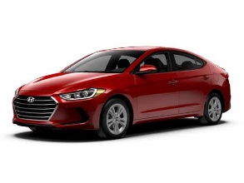
2016 Porsche 911 - Turbo S Cabriolet​ - $178,000 (New)  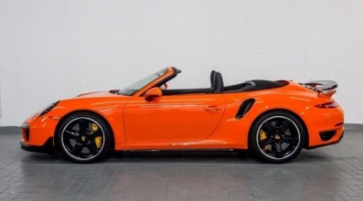 | 2017 Nissan Sentra SV - SV 4dr Sedan - $13,915 (New)  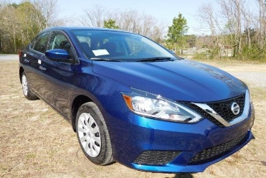 | 2015 Mitsubishi Lancer ES - ES 4dr Sedan CVT - $8,977 (Used)  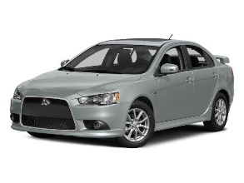
2008 Volvo S80 T6 - AWD T6 4dr Sedan Luxury - $8,900 (Used)  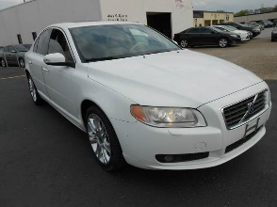 | 2017 Jeep Cherokee - Altitude - $22,390 (New)  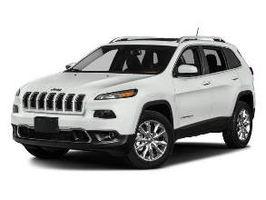 | 2017 Ford Taurus SEL - SEL 4dr Sedan - $26,734 (New)  

Below is an example of a participant’s screen view with 10 options. As previously mentioned, the actual sizes and number of options that are simultaneously displayed (i.e., able to be compared without scrolling the page down) depends on the participant’s monitor size, screen resolution, and current level of internet browser zoom.
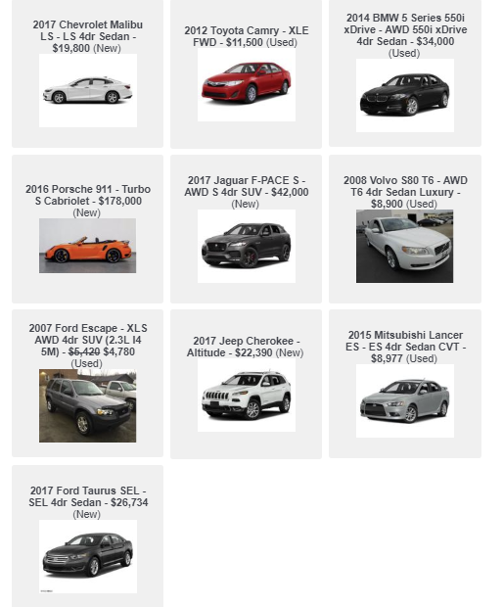

Experiment 5: Movie Options (Easy Condition)
The options were displayed in two columns.
Mission: Impossible - Fallout |  |  |  | The Sisters Brothers
 | Genre: Action, Thriller  Length: 2h 27m |  |  |  | Genre: Comedy, Western  Length: 2h 1m
Fast Color |  |  |  | Changeland
 |  | Genre: Science Fiction, Thriller  Length: 1h 42m |  |  |  | Genre: Comedy, Drama  Length: 1h 26m

The Good Guy |  |  | Running With the Devil
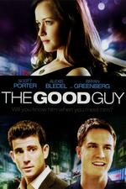 | Genre: Comedy  Length: 1h 42m |  |  | Genre: Action, Crime  Length: 1h 40m
All Square |  |  | The Lincoln Lawyer
 | Genre: Comedy  Length: 1h 39m |  |  | Genre: Crime, Legal  Length: 2h 0m

High-Rise |  |  |  | Leap Year
 | Genre: Comedy, Drama  Length: 1h 59m |  |  |  |  | Genre: Comedy, Romance  Length: 1h 40m
What Men Want |  |  |  |  | And So It Goes
 | Genre: Comedy, Romance  Length: 1h 57m |  |  |  |  |  | Genre: Comedy, Romance  Length: 1h 34m

Fighting With My Family |  |  |  | Backtrace
 | Genre: Comedy, Drama  Length: 1h 48m |  |  | 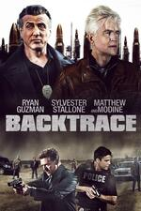 |  | Genre: Adventure, Thriller  Length: 1h 27m
The Commuter |  |  |  |  | Daylight's End
 | Genre: Mystery, Thriller  Length: 1h 45m |  |  |  |  |  | Genre: Action, Horror  Length: 1h 45m

Arbitrage |  |  | Under the Tree
 | Genre: Drama, Thriller  Length: 1h 47m |  |  | Genre: Comedy  Length: 1h 29m
Dog Days |  |  | The Osiris Child
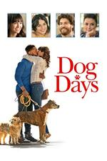 | Genre: Comedy, Romance  Length: 1h 53m |  |  | Genre: Action, Science Fiction  Length: 1h 39m

The Prince |  |  |  |  | The Colony
 | Genre: Action, Thriller  Length: 1h 33m |  |  |  | 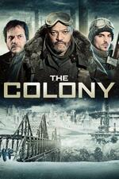 |  | Genre: Horror, Thriller  Length: 1h 33m
I Kill Giants |  |  |  | Black Rock
 | Genre: Fantasy, Thriller  Length: 1h 46m |  |  |  |  | Genre: Thriller, Horror  Length: 1h 19m

Along With the Gods: The Two Worlds
 | Genre: Fantasy, Adventure  Length: 2h 20m

Below is an example of a participant’s screen view with 4 options:
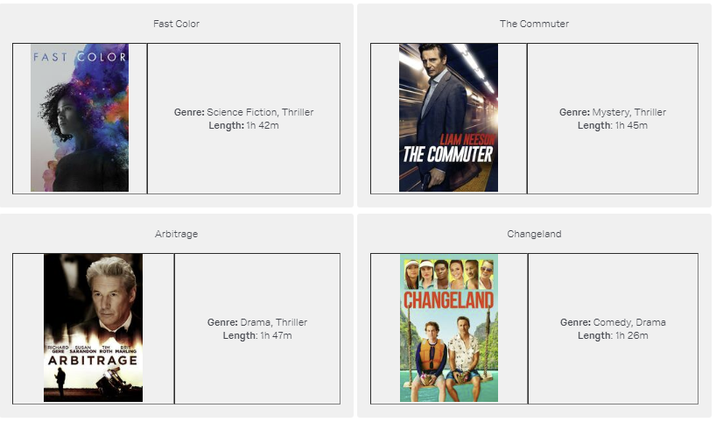

Experiment 5: Movie Options (Moderate Condition)
Mission: Impossible - Fallout  Ethan Hunt and the IMF team join forces with CIA assassin August Walker to prevent a disaster of epic proportions. |  |  |  |  |  |  |  |  |  |  | The Sisters Brothers  Based on Patrick Dewitt’s acclaimed novel, Eli and Charlie Sisters are hired to kill a prospector who has stolen from their boss. The story, a genre-hybrid with comedic elements, takes place in Oregon in 1851.
 | Genre: Action, Thriller  Released: 2018  Length: 2h 27m  MPAA Rating: PG-13 |  |  |  |  |  |  |  |  |  |  |  |  | Genre: Comedy, Western  Released: 2018  Length: 2h 1m  MPAA Rating: R
Fast Color  Hunted by mysterious forces and a local sheriff, a young woman with supernatural abilities flees back to her family-and unearths the depths of the power within her. |  |  |  |  |  |  |  |  |  |  | Changeland  Directed by and starring Seth Green, the film follows two estranged best friends on a life-changing trip to Thailand. This epic journey reminds them that there's no problem that friendship and a few rounds in a Thai boxing ring can't fix.
 |  |  | Genre: Science Fiction, Thriller  Released: 2018  Length: 1h 42m  MPAA Rating: PG-13 |  |  |  |  |  |  |  |  |  |  |  | Genre: Comedy, Drama  Released: 2019  Length: 1h 26m  MPAA Rating: R
The Good Guy  The girlfriend of a hotshot Wall Street trader finds herself falling for his protege. |  |  |  |  |  |  |  |  |  |  | Running With the Devil  When a cocaine shipment is compromised to the dismay of a drug cartel's CEO, known simply as The Boss, he orders his most trusted henchman on a dangerous journey to audit the company's supply chain.
 | Genre: Comedy  Released: 2010  Length: 1h 31m  MPAA Rating: R |  |  |  |  |  |  |  |  |  |  |  |  | Genre: Action, Crime  Released: 2019  Length: 1h 40m  MPAA Rating: R
All Square  A down-on-his-luck bookie befriends an ex-girlfriend's son and begins taking bets on his youth league baseball games, creating chaos in the community. |  |  |  |  |  |  |  |  |  |  | The Lincoln Lawyer  Michael "Mick" Haller, is a slick, charismatic Los Angeles criminal defense attorney who operates out of the back of his Lincoln Continental sedan.
 | Genre: Comedy  Released: 2018  Length: 1h 40m  MPAA Rating: TVMA |  |  |  |  |  |  |  |  |  |  |  |  | Genre: Crime, Legal  Released: 2015  Length: 1h 54m  MPAA Rating: R
High-Rise  Life seems like paradise to the solitude-seeking Laing. But, as power outages become more frequent and building flaws emerge, mainly on the lower floors, social strata begins to crumble and the building descends into a class war. |  |  |  |  |  |  |  |  |  |  | Leap Year  Amy Adams and Matthew Goode star in Leap Year, a romantic comedy that follows one woman’s determined quest to get married to the perfect guy…despite what fate has in store for her.
 | Genre: Comedy, Drama  Released: 2015  Length: 1h 59m  MPAA Rating: R |  |  |  |  |  |  |  |  |  |  |  |  | Genre: Comedy, Romance  Released: 2010  Length: 1h 40m  MPAA Rating: PG
What Men Want  A woman is boxed out by the male sports agents in her profession, but gains an unexpected edge over them when she develops the ability to hear their thoughts. |  |  |  |  |  |  |  |  |  |  | And So It Goes  A self-absorbed realtor enlists the help of his neighbor when he's suddenly left in charge of the granddaughter he never knew existed until his estranged son drops her off at his home.
 | Genre: Comedy, Romance  Released: 2019  Length: 1h 57m  MPAA Rating: R |  |  |  |  |  |  |  |  |  |  |  |  | Genre: Comedy, Romance  Released: 2014  Length: 1h 34m  MPAA Rating: PG-13
Fighting With My Family  Former wrestler Ricky makes a living performing with his family. When they get the chance to audition for WWE, the family's dream seems to be coming true. However, they find out that becoming a WWE Superstar demands more than they ever imagined possible. |  |  |  |  |  |  |  |  |  | Backtrace  Twenty years after a botched robbery, three grifters kidnap an amnesia patient to jog his memory and find the long-lost money.
 | Genre: Comedy, Drama  Released: 2010  Length: 1h 48m  MPAA Rating: PG-13 |  |  |  |  |  |  |  |  |  |  |  | Genre: Adventure, Thriller  Released: 2018  Length: 1h 27m  MPAA Rating: R
The Commuter  A man who gets caught up in a criminal conspiracy during his daily commute home and works against the clock to stop a deadly attack to save the lives of his fellow train passengers. |  |  |  |  |  |  |  |  |  | Daylight's End  A rogue drifter agrees to guide a band of survivors to sanctuary after a plague turns most of humanity into monsters.
 | Genre: Mystery, Thriller  Released: 2018  Length: 1h 45m  MPAA Rating: PG-13 |  |  |  |  |  |  |  |  |  |  |  | Genre: Action, Horror  Released: 2016  Length: 1h 45m  MPAA Rating: TVMA
Arbitrage  Richard Gere leads an all-star cast in an electrifying thriller about a hedge-fund magnate whose fortunes turn when a deadly error threatens to destroy both his financial empire and his family. |  |  |  |  |  |  |  |  |  |  |  | Under the Tree  After moving back home, a man gets sucked into a dispute between his parents and their neighbors over an old and beautiful tree. What starts as a typical spat unexpectedly and violently reaches a boiling point, soon spiraling out of control.
 |  | Genre: Drama, Thriller  Released: 2012  Length: 1h 47m  MPAA Rating: R |  |  |  |  |  |  |  |  |  |  |  |  |  | Genre: Comedy  Released: 2017  Length: 1h 29m  MPAA Rating: PG
Dog Days  Dog Days is a hilarious and heartfelt comedy that follows the lives of multiple dog owners and their beloved fluffy pals around Los Angeles. When these human and canines’ paths start to intertwine, their lives begin changing in ways they never expected. |  |  |  |  |  |  |  |  | The Osiris Child  When a dangerous outbreak threatens to destroy everyone living on a newly colonized planet, Lt. Kane Sommerville goes against orders and leaves his station to rescue his young daughter before it's too late.
 |  |  | Genre: Comedy, Romance  Released: 2018  Length: 1h 53m  MPAA Rating: PG |  |  |  |  |  |  |  |  |  | Genre: Action, Science Fiction  Released: 2017  Length: 1h 39m  MPAA Rating: R

The Prince  A retired assassin is drawn back into the life he gave up when his daughter is kidnapped. To rescue her, he must confront his former rival. |  |  | The Colony  Years ago, winter came and left. Survivors have tried to build a new society underground, but they soon learn the real danger is not from the ice and cold, but from their fellow survivors.
 | Genre: Action, Thriller  Released: 2014  Length: 1h 33m  MPAA Rating: R |  |  | Genre: Horror, Thriller  Released: 2013  Length: 1h 33m  MPAA Rating: R
I Kill Giants  A teen must face her fears in increasingly dangerous ways when horrible giants threaten to destroy her small town. |  |  | Black Rock  Three childhood friends set aside their personal issues and reunite for a girls' weekend on a remote island off the coast of Maine. One wrong move turns their weekend getaway into a deadly fight for survival.
 | Genre: Fantasy, Thriller  Released: 2017  Length: 1h 46m  MPAA Rating: R |  |  |  | Genre: Thriller, Horror  Released: 2013  Length: 1h 19m  MPAA Rating: R

Along With the Gods: The Two Worlds
In this action-packed fantasy epic, a firefighter is taken to the afterlife by three guardians, where only after passing seven trials and proving he lived a noble life will he be able to reincarnate
 | Genre: Fantasy, Adventure  Released: 2017  Length: 2h 20m  MPAA Rating: PG

Below is an example of a participant’s screen view with two options.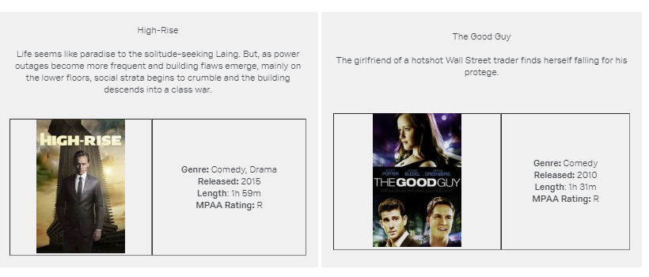

Experiment 5: Movie Options (Difficult Condition)
The options were displayed in two columns.
Mission: Impossible - Fallout  Ethan Hunt and the IMF team join forces with CIA assassin August Walker to prevent a disaster of epic proportions. Arms dealer John Lark and a group of terrorists known as the Apostles plan to use three plutonium cores for a simultaneous nuclear attack on the Vatican, Jerusalem and Mecca, Saudi Arabia. When the weapons go missing, Ethan and his crew find themselves in a desperate race against time to prevent them from falling into the wrong hands. |  |  |  | The Sisters Brothers  It's 1851, and Charlie and Eli Sisters are both brothers and assassins, boys grown to men in a savage and hostile world. The Sisters brothers find themselves on a journey through the Northwest, bringing them to the mountains of Oregon, a dangerous brothel in the small town of Mayfield, and eventually, the gold rush land of California -- an adventure that tests the deadly family ties that bind.
 | Genre: Action, Thriller  Released: July 27, 2018  Length: 2h 27m  IMDb Rating: 7.7/10  Google users: 94% liked this movie  Rotten Tomatoes Rating: 97%  Metacritic: 86%  Box office: 791.1 million USD  Budget: 178 million USD  Director: Christopher McQuarrie  Available on: YouTube, Google Play, Amazon Prime, Vudu, Hulu  MPAA Rating: PG-13 |  |  |  | Genre: Comedy, Western  Released: September 19, 2018  Length: 2h 1m  IMDb Rating: 7.0/10  Google users: 81% liked this movie  Rotten Tomatoes Rating: 87%  Metacritic: 78%  Box office: N/A  Budget: 38 million USD  Director: Jacques Audiard  Available on: YouTube, Google Play, Amazon Prime, Vudu, Hulu  MPAA Rating: R
Fast Color  Hunted by mysterious forces, a young woman who has supernatural abilities must go on the run when her powers are discovered. With nowhere else to go, she flees back to her family and the farmhouse she abandoned long ago. There, while being pursued by the local sheriff, she begins to mend the broken relationships with her mother and daughter and learns that the power she needed was inside her all along. |  |  |  | Changeland  On the eve of his anniversary, Brandon discovers his wife is having an affair. Distraught and without hesitation he jumps on a plane with his childhood friend Dan on a prepaid trip to Thailand. Once in Thailand, the pair go on a series of excursions and tours intended for a happy couple. Upon their journey they meet two eccentric tour guides Ian and Pen who show them the wonders of Thailand and bring the two friends back together through life, love, and good fun.
 |  | Genre: Science Fiction, Thriller  Released: April 19, 2019  Length: 1h 42m  IMDb Rating: 5.9/10  Google users: 87% liked this movie  Rotten Tomatoes Rating: 82%  Metacritic: 64%  Box office: N/A  Budget: N/A  Director: Julia Hart  Available on: YouTube, Google Play, Amazon Prime, Vudu, Hulu  MPAA Rating: PG-13 |  |  |  | Genre: Comedy, Drama  Released: June 7, 2019  Length: 1h 26m  IMDb Rating: 5.7/10  Google users: 77% liked this movie  Rotten Tomatoes Rating: 63%  Metacritic: 42%  Box office: N/A  Budget: N/A  Director: Seth Green  Available on: YouTube, Google Play, Amazon Prime, Vudu, Hulu  MPAA Rating: R

The Good Guy  Beth (Alexis Bledel), an urban conservationist, wants it all: a good job, good friends, and a good guy to share her life and love of New York. When Beth meets Tommy (Scott Porter), a Wall Street whiz, she falls head over heels in love. It seems that everything is falling into place, but romantic complications arise when Beth meets Daniel, Tommy's sensitive and handsome colleague. |  |  | Running With the Devil  When a cocaine shipment is compromised to the dismay of a drug cartel's CEO, known simply as The Boss, he orders his most trusted henchman on a dangerous journey to audit the company's supply chain. As the drugs make their perilous trek across international borders, past gangsters, refiners, and couriers, they are also being tracked by Federal Agents. When The Cook realizes where the network is breaking down, it may be too late to keep the cartel satisfied.
 | Genre: Comedy  Released: February 19, 2010  Length: 1h 42m  IMDb Rating: 5.8/10  Google users: 75% liked this movie  Rotten Tomatoes Rating: 35%  Metacritic: 47%  Box office: N/A  Budget: 3.2 million USD  Director: Julio DePietro  Available on: YouTube, Google Play, Amazon Prime, Vudu, Hulu  MPAA Rating: R |  |  | Genre: Action, Crime  Released: October 24, 2019  Length: 1h 40m  IMDb Rating: 5.4/10  Google users: 68% liked this movie  Rotten Tomatoes Rating: 25%  Metacritic: 42%  Box office: N/A  Budget: N/A  Director: Jason Cabell  Available on: YouTube, Google Play, Amazon Prime, Vudu, Hulu  MPAA Rating: R

All Square  John Zbikowski is a down-on-his-luck, small town bookie who develops an unlikely friendship with Brian, his ex-girlfriend's 12-year-old son. When Zbikowski's clients don't pay their debts, he tries to recoup his earnings by taking bets on Brian's baseball games. |  |  | The Lincoln Lawyer  Mick Haller (Matthew McConaughey) is a charismatic defense attorney who does business out of his Lincoln Continental sedan. Mick spends most of his time defending petty crooks and other bottom-feeders, so it comes as quite a surprise when he lands the case of a lifetime: defending a Beverly Hills playboy (Ryan Phillippe) who is accused of attempted murder. However, what Mick initially thinks is an open-and-shut case with a big monetary reward develops into something more sinister.
 | Genre: Comedy  Released: October 12, 2018  Length: 1h 39m  IMDb Rating: 5.8/10  Google users: 82% liked this movie  Rotten Tomatoes Rating: 91%  Metacritic: 65%  Box office: N/A  Budget: N/A  Director: John Hyams  Available on: YouTube, Google Play, Amazon Prime, Vudu, Hulu  MPAA Rating: TVMA |  |  | Genre: Crime, Legal  Released: March 10, 2011  Length: 2h 0m  IMDb Rating: 7.3/10  Google users: 91% liked this movie  Rotten Tomatoes Rating: 84%  Metacritic: 63%  Box office: 87.1 million USD  Budget: 40 million USD  Director: Brad Furman  Available on: YouTube, Google Play, Amazon Prime, Vudu, Hulu  MPAA Rating: R

High-Rise  HIGH-RISE stars Hiddleston as Dr. Robert Laing, the newest resident of a luxurious apartment in a high-tech concrete skyscraper whose lofty location places him amongst the upper class. Laing quickly settles into high society life and meets the building's eccentric tenants. Life seems like paradise to the solitude-seeking Laing. But as power outages become more frequent and building flaws emerge, particularly on the lower floors, the regimented social strata begins to crumble and the building becomes a battlefield in a literal class war. |  |  | Leap Year  When yet another anniversary passes without a marriage proposal from her boyfriend, Anna (Amy Adams) decides to take action. Aware of a Celtic tradition that allows women to pop the question on Feb. 29, she plans to follow her lover to Dublin and ask him to marry her. Fate has other plans, however, and Anna winds up on the other side of the Emerald Isle with handsome, but surly, Declan -- an Irishman who may just lead Anna down the road to true love.
 | Genre: Comedy, Drama  Released: May 13, 2016  Length: 1h 59m  IMDb Rating: 5.6/10  Google users: 74% liked this movie  Rotten Tomatoes Rating: 60%  Metacritic: 65%  Box office: 4.1 million USD  Budget: 8 million USD  Director: Ben Wheatley  Available on: YouTube, Google Play, Amazon Prime, Vudu, Hulu  MPAA Rating: R |  |  | Genre: Comedy, Romance  Released: January 8, 2010  Length: 1h 40m  IMDb Rating: 6.5/10  Google users: 93% liked this movie  Rotten Tomatoes Rating: 23%  Metacritic: 33%  Box office: 32.6 million USD  Budget: 19 million USD  Director: Anand Tucker  Available on: YouTube, Google Play, Amazon Prime, Vudu, Hulu  MPAA Rating: PG

What Men Want  Passed up for a well-deserved promotion, sports agent Ali Davis wonders what else she needs to do to succeed in a man's world. Hoping to find answers from a psychic, Ali drinks a weird concoction that suddenly allows her to hear what men are thinking. Using her newfound ability, Ali starts to turn the tables on her obnoxious male colleagues while racing to sign the next basketball superstar. |  |  | And So It Goes  Nobody likes real-estate agent Oren Little (Michael Douglas), and he prefers it that way. He's deliberately mean to anyone who crosses his path and wants nothing more than to sell one final house and retire. Oren's life turns upside-down when his estranged son drops off a granddaughter (Sterling Jerins) he didn't know existed. Oren has no idea how to take care of a child, so he pawns the girl off on his neighbor, Leah (Diane Keaton) -- but he learns how to open his heart eventually.
 | Genre: Comedy, Romance  Released: February 8, 2019  Length: 1h 57m  IMDb Rating: 5.2/10  Google users: 82% liked this movie  Rotten Tomatoes Rating: 42%  Metacritic: 49%  Box office: 72.2 million USD  Budget: 20 million USD  Director: Adam Shankman  Available on: YouTube, Google Play, Amazon Prime, Vudu, Hulu  MPAA Rating: R |  |  | Genre: Comedy, Romance  Released: July 25, 2014  Length: 1h 34m  IMDb Rating: 5.8/10  Google users: 86% liked this movie  Rotten Tomatoes Rating: 18%  Metacritic: 38%  Box office: 25.3 million USD  Budget: 18 million USD  Director: Rob Reiner  Available on: YouTube, Google Play, Amazon Prime, Vudu, Hulu  MPAA Rating: PG-13

Fighting With My Family  Born into a tight-knit wrestling family, Paige and her brother Zak are ecstatic when they get the once-in-a-lifetime opportunity to try out for the WWE. But when only Paige earns a spot in the competitive training program, she must leave her loved ones behind and face this new cutthroat world alone. Paige's journey pushes her to dig deep and ultimately prove to the world that what makes her different is the very thing that can make her a star. |  |  | Backtrace  After suffering a brain injury from a bank heist gone wrong, MacDonald develops amnesia and is put into a prison psychiatric ward. Following his seventh year of incarceration, he is coerced by an inmate and a ward doctor to break out of prison, and he is injected with a serum that forces him to relive the life he has forgotten. MacDonald must now elude a local detective, a toughened FBI agent, and the drug's dangerous side effects to recover the stolen money.
 | Genre: Comedy, Drama  Released: February 27, 2019  Length: 1h 48m  IMDb Rating: 7.1/10  Google users: 91% liked this movie  Rotten Tomatoes Rating: 93%  Metacritic: 68%  Box office: 41.5 million USD  Budget: 11 million USD  Director: Stephen Merchant  Available on: YouTube, Google Play, Amazon Prime, Vudu, Hulu  MPAA Rating: PG-13 |  |  | Genre: Adventure, Thriller  Released: December 14, 2018  Length: 1h 27m  IMDb Rating: 3.7/10  Google users: 59% liked this movie  Rotten Tomatoes Rating: 11%  Metacritic: 45%  Box office: 1.2 million USD  Budget: N/A  Director: Brian A. Miller  Available on: YouTube, Google Play, Amazon Prime, Vudu, Hulu  MPAA Rating: R

The Commuter  Insurance salesman Michael is on his daily commute home, which quickly becomes anything but routine. After being contacted by a mysterious stranger, Michael is forced to uncover the identity of a hidden passenger on the train before the last stop. As he works against the clock to solve the puzzle, he realizes a deadly plan is unfolding, and he is unwittingly caught up in a criminal conspiracy that carries life and death stakes for everyone on the train. |  |  | Daylight's End  Years after a mysterious plague has devastated the planet and turned most of humanity into blood-hungry creatures, a rogue drifter on a vengeful hunt stumbles across a band of survivors in an abandoned police station and reluctantly agrees to try to help them defend themselves and escape to the sanctuary they so desperately need.
 | Genre: Mystery, Thriller  Released: January 12, 2018  Length: 1h 45m  IMDb Rating: 6.3/10  Google users: 86% liked this movie  Rotten Tomatoes Rating: 56%  Metacritic: 56%  Box office: 119.9 million USD  Budget: 40 million USD  Director: Jaume Collet-Serra  Available on: YouTube, Google Play, Amazon Prime, Vudu, Hulu  MPAA Rating: PG-13 |  |  | Genre: Action, Horror  Released: April 16, 2016  Length: 1h 45m  IMDb Rating: 5.4/10  Google users: 85% liked this movie  Rotten Tomatoes Rating: N/A  Metacritic: N/A  Box office: N/A  Budget: 2 million USD  Director: William Kaufman  Available on: YouTube, Google Play, Amazon Prime, Vudu, Hulu  MPAA Rating: TVMA

Arbitrage  As he approaches his 60th birthday, New York hedge-fund magnate Robert Miller (Richard Gere) is the picture of success -- at least on the surface. In reality, Miller is in over his head, trying desperately to sell his empire to a big bank before the authorities and his family uncover the depth of his fraud. Unexpectedly, a critical error forces Miller to juggle family, business and crime with the aid of a former associate, but a detective's (Tim Roth) suspicions mean it may already be too late. |  |  | Under the Tree  UNDER THE TREE follows a man who is accused of adultery and forced to move in with his parents. While he fights for custody of his four-year-old daughter, he is gradually sucked into a dispute between his parents and their neighbors over an old and beautiful tree. What starts as a typical spat between suburban neighbors unexpectedly and violently reaches a boiling point, soon spiraling out of control.
 | Genre: Drama, Thriller  Released: September 14, 2012  Length: 1h 47m  IMDb Rating: 6.6/10  Google users: 81% liked this movie  Rotten Tomatoes Rating: 88%  Metacritic: 73%  Box office: 35.5 million USD  Budget: 12 million USD  Director: Nicholas Jarecki  Available on: YouTube, Google Play, Amazon Prime, Vudu, Hulu  MPAA Rating: R |  |  | Genre: Comedy  Released: August 31, 2012  Length: 1h 29m  IMDb Rating: 6.6/10  Google users: 78% liked this movie  Rotten Tomatoes Rating: 85%  Metacritic: 75%  Box office: 612,628 USD  Budget: N/A  Director: Hafsteinn Gunnar  Available on: YouTube, Google Play, Amazon Prime, Vudu, Hulu  MPAA Rating: PG

Dog Days  Elizabeth is a charming anchorwoman who seeks advice from her dog's therapist. Tara is a spunky barista who dreams of a life beyond the coffee shop. Daisy is a dog walker who's enamoured with a client. Garrett pines for a woman while trying to keep his adopt-a-dog business afloat. The beloved canines in their lives soon start to influence their careers, friendships and romantic relationships in funny and unexpected ways. |  |  | The Osiris Child  When a dangerous outbreak threatens to destroy everyone living on a newly colonized planet, Lt. Kane Sommerville (Daniel MacPherson) goes against orders and leaves his station to rescue his young daughter (Teagan Croft). Desperate to get to her before it's too late, Kane enlists the help of an escaped prisoner (Kellan Lutz) as they battle their way through the chaos of a planet on the verge of annihilation. With the odds stacked against them, saving his little girl may be humanity's last chance at survival.
 | Genre: Comedy, Romance  Released: August 8, 2018  Length: 1h 53m  IMDb Rating: 6.2/10  Google users: 90% liked this movie  Rotten Tomatoes Rating: 63%  Metacritic: 47%  Box office: 7.6 million USD  Budget: 10 million USD  Director: Ken Marino  Available on: YouTube, Google Play, Amazon Prime, Vudu, Hulu  MPAA Rating: PG |  |  | Genre: Action, Science Fiction  Released: May 18, 2017  Length: 1h 39m  IMDb Rating: 5.6/10  Google users: 80% liked this movie  Rotten Tomatoes Rating: 63%  Metacritic: 55%  Box office: N/A  Budget: N/A  Director: Shane Abbess  Available on: YouTube, Google Play, Amazon Prime, Vudu, Hulu  MPAA Rating: N/A

The Prince  Jason Patric, Bruce Willis, and John Cusack star in the noir, crime thriller The Prince. Paul (Jason Patric) is a mafia hit-man in New Orleans, and with a baby on the way, he wants out. Paul thinks the only way to do that is to kill his boss (Bruce Willis). With a car bomb in place, Paul waits for his boss to leave for the day, but is shocked to see the bosses wife and daughter get into the car instead. After the tragedy, Paul and his family flea and for 18 years, live in peace, but all that changes when his daughter goes down to New Orleans for a weekend getaway and disappears. When his daughter goes missing, Paul is forced to reconnects with his old gangster contacts in order to save her life. |  |  | The Colony  By 2045, humans have built weather machines to control the warming climate due to climate change and global warming. The machines break down when one day it begins to snow and doesn't stop. Whatever humans remain live in underground bunkers to escape the extreme cold. Their challenges are controlling disease and producing sufficient food. Two soldiers, Briggs (Laurence Fishburne) and Mason (Bill Paxton) are the leaders of one such bunker, Colony 7. Briggs, Sam (Kevin Zegers) and Graydon (Atticus Dean Mitchell) travel to nearby Colony 5 after receiving a distress signal. Briggs leaves Sam's lover Kai (Charlotte Sullivan) in charge of the colony while he's gone, much to Mason's chagrin. Upon arrival, they find Colony 5 covered in blood.
 | Genre: Action, Thriller  Released: August 22, 2014  Length: 1h 33m  IMDb Rating: 4.6/10  Google users: 76% liked this movie  Rotten Tomatoes Rating: 63%  Metacritic: N/A  Box office: N/A  Budget: 18 million USD  Director: Randall Emmett  Available on: YouTube, Google Play, Amazon Prime, Vudu, Hulu  MPAA Rating: R |  |  | Genre: Horror, Thriller  Released: September 20, 2013  Length: 1h 33m  IMDb Rating: 5.3/10  Google users: 79% liked this movie  Rotten Tomatoes Rating: N/A  Metacritic: N/A  Box office: N/A  Budget: 16 million USD  Director: Jeff Renfroe  Available on: YouTube, Google Play, Amazon Prime, Vudu, Hulu  MPAA Rating: R

I Kill Giants  Barbara Thorson (Madison Wolfe) is a teenage girl who escapes the realities of school and a troubled family life by retreating into her magical world of fighting evil giants. With the help of her new friend Sophia (Sydney Wade) and her school counselor (Zoe Saldana), Barbara learns to face her fears and battle the giants that threaten her world. |  |  | Black Rock  Sarah (Kate Bosworth) has tricked her two best friends, Lou (Lake Bell) and Abby (Katie Aselton, also the director) — who are embroiled in a longtime feud — into showing up for a camping trip with her on the tiny Maine island where they spent summers as kids. Reluctantly, the two agree to the reunion, and soon they’re all traipsing through the woods in search of their old buried time capsule, with Abby and Lou pausing to open old wounds and bicker. One wrong move turns their weekend getaway into a deadly fight for survival.
 | Genre: Fantasy, Thriller  Released: March 23, 2018  Length: 1h 46m  IMDb Rating: 6.2/10  Google users: 73% liked this movie  Rotten Tomatoes Rating: 77%  Metacritic: 74%  Box office: N/A  Budget: N/A  Director: Anders Walter  Available on: YouTube, Google Play, Amazon Prime, Vudu, Hulu  MPAA Rating: R |  |  | Genre: Thriller, Horror  Released: May 17, 2013  Length: 1h 19m  IMDb Rating: 4.7/10  Google users: 68% liked this movie  Rotten Tomatoes Rating: 52%  Metacritic: 46%  Box office: N/A  Budget: N/A  Director: Katie Aselton  Available on: YouTube, Google Play, Amazon Prime, Vudu, Hulu  MPAA Rating: R

Along With the Gods: The Two Worlds
After dying unexpectedly, firefighter Ja-hong is taken to the afterlife by three guardians, where only after passing seven trials and proving he lived a noble life will he be able to reincarnate. Based on the wildly popular webcomic, ALONG WITH THE GODS: THE TWO WORLDS is a star-studded, action-packed fantasy epic about life, death, rebirth, and the unseen forces that guide us through all.

 | Genre: Fantasy, Adventure  Released: December 20, 2017  Length: 2h 20m  IMDb Rating: 7.3/10  Google users: 95% liked this movie  Rotten Tomatoes Rating: 63%  Metacritic: 60%  Box office: 1.11 million USD  Budget: N/A  Director: Yong-hwa Kim  Available on: YouTube, Google Play, Amazon Prime, Vudu, Hulu  MPAA Rating: PG

Below is an example of a participant’s screen view with three options.
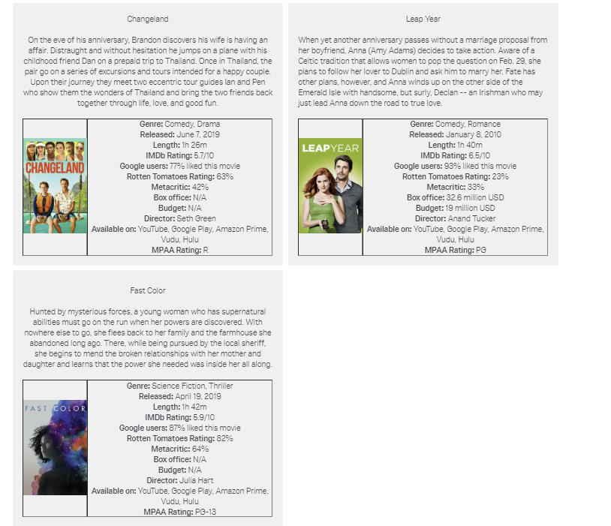

Experiment 6: Laptop Options (Easy Condition)
The options were displayed in three columns.
Laptop | UTZ | MPS | YZZ
Processor | 7th Gen Intel Core i3-7350K | 7th Gen Intel Core i5-7600K | 7th Gen Intel Core i7-7700K
Memory | 2GB DDR3 RAM | 2GB DDR4 RAM | 4GB DDR3 RAM
Storage | 128GB SSD | 128GB SSD | 128GB SSD + 128GB HDD
GPU Type | Integrated | Integrated | Integrated
GPU Card | Intel HD Graphics 400 | Intel HD Graphics 500 | Intel HD Graphics 620
Battery Life | 1.5 hours | 1.5 hours | 1.5 hours
Screen Size | 12" | 12" | 13"
Resolution | HD (1366 x 768) | HD (1366 x 768) | Full HD (1920 x 1080)
Avg. Customer Review | 2.0/5 | 2.2/5 | 2.5/5

Laptop | NPS | MGS | HPE
Processor | 8th Gen Intel Core i3-8350K | 8th Gen Intel Core i5-8600K | 8th Gen Intel Core i7-8700K
Memory | 4GB DDR4 RAM | 8GB DDR3 RAM | 8GB DDR4 RAM
Storage | 256GB SSD | 256GB SSD | 256GB SSD + 256GB HDD
GPU Type | Integrated | Dedicated (NVIDIA) | Dedicated (NVIDIA)
GPU Card | Intel Iris Plus Graphics 650 | GeForce 9 series GTX 950 | GeForce 9 series GTX 980
Battery Life | 2 hours | 2 hours | 2 hours
Screen Size | 13" | 13" | 14"
Resolution | Full HD (1920 x 1080) | Full HD (1920 x 1080) | Full HD (1920 x 1080)
Avg. Customer Review | 3.0/5 | 3.2/5 | 3.5/5

Laptop | YMM | XPT | XPX
Processor | 8th Gen Intel Core i9-8950HK | 9th Gen Intel Core i3-9350KF | 9th Gen Intel Core i5-9600K
Memory | 12GB DDR3 RAM | 12GB DDR4 RAM | 16GB DDR3 RAM
Storage | 512GB SSD | 512GB SSD | 512GB SSD + 512GB HDD
GPU Type | Dedicated (NVIDIA) | Dedicated (NVIDIA) | Dedicated (NVIDIA)
GPU Card | GeForce 10 series GTX 1050 | GeForce 16 series GTX 1660 | GeForce 16 series GTX 1660
Battery Life | 3 hours | 3 hours | 4 hours
Screen Size | 14" | 14" | 15"
Resolution | Full HD (1920 x 1080) | Full HD (1920 x 1080) | Full HD (1920 x 1080)
Avg. Customer Review | 3.5/5 | 3.8/5 | 3.8/5

Laptop | YZP | NPP | UXT
Processor | 9th Gen Intel Core i7-9700K | 9th Gen Intel Core i9-9900K | 10th Gen Intel Core i3-10110U
Memory | 16GB DDR4 RAM | 24GB DDR3 RAM | 24GB DDR4 RAM
Storage | 1TB SSD | 1TB SSD | 1TB SSD + 1TB HDD
GPU Type | Dedicated (NVIDIA) | Dedicated (NVIDIA) | Dedicated (NVIDIA)
GPU Card | GeForce 20 series RTX 2060 | GeForce 20 series RTX 2060S | GeForce 20 series RTX 2070
Battery Life | 5 hours | 6 hours | 7 hours
Screen Size | 15" | 15" | 15"
Resolution | Full HD (1920 x 1080) | 4K UHD (3840 x 2160) | 4K UHD (3840 x 2160)
Avg. Customer Review | 4.0/5 | 4.0/5 | 4.2/5

Laptop | MPE | UZS | MPX
Processor | 10th Gen Intel Core i5-10210U | 10th Gen Intel Core i7-10710U | 10th Gen Intel Core i9-10900K
Memory | 32GB DDR3 RAM | 32GB DDR4 RAM | 64GB DDR4 RAM
Storage | 2TB SSD | 2TB SSD | 2TB SSD + 2TB HDD
GPU Type | Dedicated (NVIDIA) | Dedicated (NVIDIA) | Dedicated (NVIDIA)
GPU Card | GeForce 20 series RTX 2070S | GeForce 20 series RTX 2080 | GeForce 20 series RTX 2080S
Battery Life | 8 hours | 9 hours | 10 hours
Screen Size | 17" | 17" | 17"
Resolution | 4K UHD (3840 x 2160) | 4K UHD (3840 x 2160) | 4K UHD (3840 x 2160)
Avg. Customer Review | 4.5/5 | 4.8/5 | 4.8/5
Example of a participant’s view – 6 options:
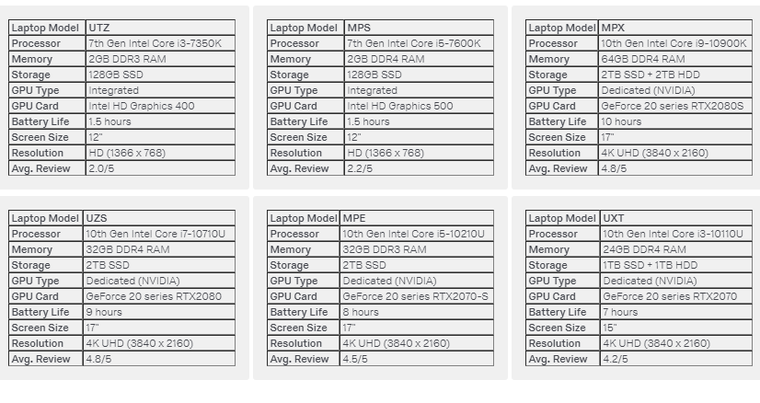

Experiment 6: Laptop Options (Difficult Condition)

Laptop | UTZ | MPS | YZZ
Processor | 8th Gen Intel Core i9-8950HK | 9th Gen Intel Core i7-9700K | 7th Gen Intel Core i3-7350K
Memory | 4GB DDR3 RAM | 8GB DDR4 RAM | 12GB DDR4 RAM
Storage | 512GB SSD | 128GB SSD | 2TB SSD
GPU Type | Integrated | Dedicated (NVIDIA) | Integrated
GPU Card | Intel HD Graphics 400 | GeForce 20 series RTX2070 | Intel HD Graphics 500
Battery Life | 8 hours | 1.5 hours | 2 hours
Screen Size | 14" | 15" | 13"
Resolution | Full HD (1920 x 1080) | 4K UHD (3840 x 2160) | Full HD (1920 x 1080)
Avg. Customer Review | 4.8/5 | 4.0/5 | 4.8/5

Laptop | NPS | MGS | HPE
Processor | 9th Gen Intel Core i5-9600K | 8th Gen Intel Core i3-8350K | 7th Gen Intel Core i5-7600K
Memory | 2GB DDR3 RAM | 12GB DDR3 RAM | 2GB DDR4 RAM
Storage | 128GB SSD + 128GB HDD | 128GB SSD | 1TB SSD + 1TB HDD
GPU Type | Dedicated (NVIDIA) | Dedicated (NVIDIA) | Dedicated (NVIDIA)
GPU Card | GeForce 9 series GTX 980 | GeForce 16 series GTX 1660 | GeForce 20 series RTX2070S
Battery Life | 9 hours | 2 hours | 10 hours
Screen Size | 12" | 17" | 14"
Resolution | Full HD (1920 x 1080) | Full HD (1920 x 1080) | 4K UHD (3840 x 2160)
Avg. Customer Review | 3.2/5 | 3.8/5 | 4.0/5

Laptop | YMM | XPT | XPX
Processor | 10th Gen Intel Core i9-10900K | 10th Gen Intel Core i7-10710U | 8th Gen Intel Core i5-8600K
Memory | 24GB DDR3 RAM | 16GB DDR3 RAM | 16GB DDR4 RAM
Storage | 256GB SSD | 256GB SSD + 256GB HDD | 512GB SSD
GPU Type | Dedicated (NVIDIA) | Dedicated (NVIDIA) | Dedicated (NVIDIA)
GPU Card | GeForce 20 series RTX2060 | GeForce 9 series GTX 950 | GeForce 20 series RTX2080S
Battery Life | 1.5 hours | 4 hours | 6 hours
Screen Size | 12" | 17" | 14"
Resolution | Full HD (1920 x 1080) | HD (1366 x 768) | 4K UHD (3840 x 2160)
Avg. Customer Review | 2.0/5 | 4.5/5 | 2.2/5

Laptop | YZP | NPP | UXT
Processor | 9th Gen Intel Core i3-9350KF | 7th Gen Intel Core i7-7700K | 10th Gen Intel Core i3-10110U
Memory | 64GB DDR4 RAM | 4GB DDR4 RAM | 32GB DDR3 RAM
Storage | 256GB SSD | 2TB SSD + 2TB HDD | 1TB SSD
GPU Type | Dedicated (NVIDIA) | Dedicated (NVIDIA) | Dedicated (NVIDIA)
GPU Card | GeForce 20 series RTX2060S | GeForce 10 series GTX 1050 | GeForce 16 series GTX 1660
Battery Life | 3 hours | 7 hours | 1.5 hours
Screen Size | 13" | 15" | 15"
Resolution | 4K UHD (3840 x 2160) | Full HD (1920 x 1080) | Full HD (1920 x 1080)
Avg. Customer Review | 3.8/5 | 3.5/5 | 3.5/5
Laptop | MPE | UZS | MPX
Processor | 10th Gen Intel Core i5-10210U | 8th Gen Intel Core i7-8700K | 9th Gen Intel Core i9-9900K
Memory | 24GB DDR4 RAM | 32GB DDR4 RAM | 8GB DDR3 RAM
Storage | 1TB SSD | 512GB SSD + 512GB HDD | 2TB SSD
GPU Type | Integrated | Integrated | Dedicated (NVIDIA)
GPU Card | Intel HD Graphics 620 | Intel Iris Plus Graphics 650 | GeForce 20 series RTX2080
Battery Life | 2 hours | 5 hours | 3 hours
Screen Size | 17" | 15" | 13"
Resolution | HD (1366 x 768) | 4K UHD (3840 x 2160) | Full HD (1920 x 1080)
Avg. Customer Review | 2.5/5 | 4.2/5 | 3.0/5

Example of a participant’s view – 5 options:
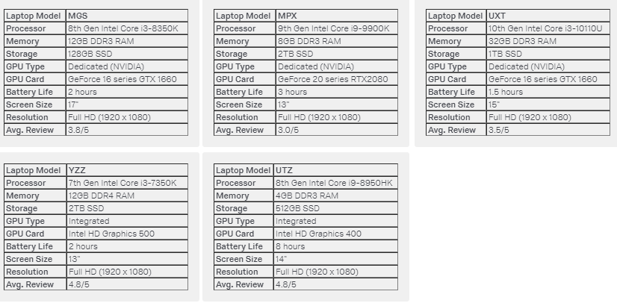

APPENDIX E: ADDITIONAL DETAILS ABOUT THE SEQUENTIAL SEARCH PROCEDURE
As we mentioned in the text and in the methodological appendix A, the choice tasks started with two options (randomly drawn from the pool of options). Participants saw these two options and a third box providing an opportunity to see an additional option. The complete pool of options for all categories we used are available in the methodological detail appendix D. In addition to exemplifying the procedure (in order to provide a better sense of what participants saw), we will provide instructions on programming the sequential search paradigm on Qualtrics.
The figure below shows the first stage of a sequential search task in which the following two options were randomly drawn: “The Westin New York” and “Fiji Hideaway Resort & Spa”.
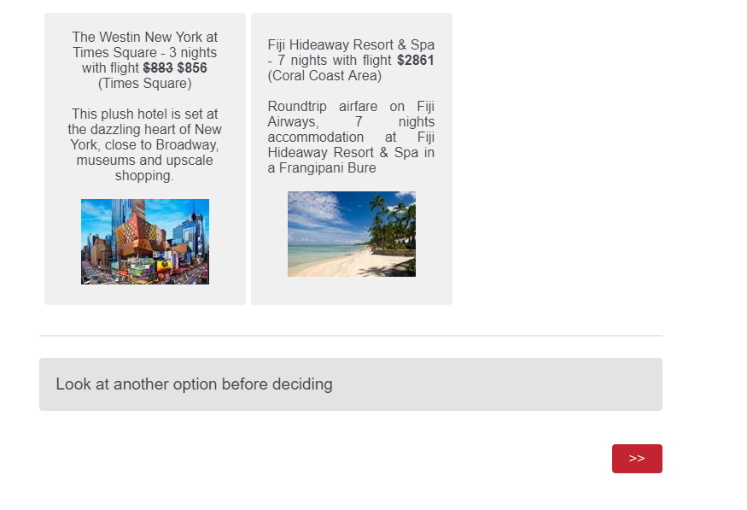
At this point, the participant can either choose one of the options or look at another option before deciding. Notice that there are two questions on the page: one with the two options and another with the option to look at another option. In addition, although there are two options, there are three columns.
On the Qualtrics end, the first step to be done on the first page of the vacation packages sequential search task is programmed by creating a multiple-choice question with 15 choices, multiple answer type (more on this below), in column position, and with 3 columns (assuming one wants 3 columns). All options (recall that there are 15 vacation packages) should be included in the question. To program the random draw of two options, use the “advanced randomization” feature, and randomly insert 2 options from the entire list of options.
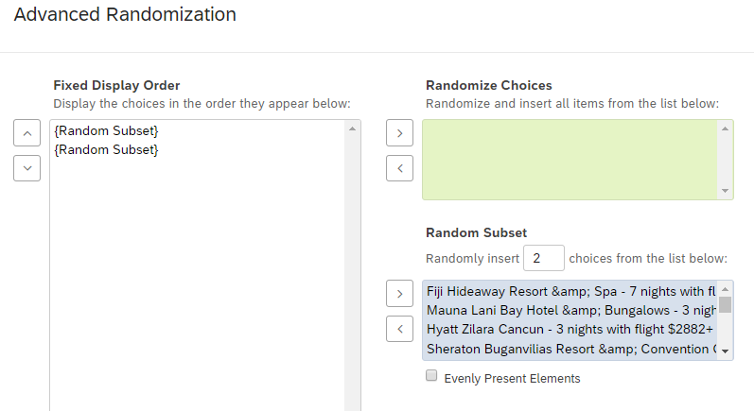
The second step is to create the “Look at another option before deciding” question, which should be also a multiple-answer question type. If the participant chooses one of the options, he/she needs to click the arrow button to be directed to the end of the block. This is programmed using the Skip Logic feature on Qualtrics. Below is one example of how the Skip Logic should be programmed. This question should be placed right after the choice set question.

If the participant decides to look at another option, he/she needs to click the arrow button to proceed to the second page of the sequential search task. This procedure cannot have the “Force Response” feature activated because participants should be able to either choose one of the options or to look at another option before deciding. If “force response” is active in either of the Qualtrics questions (the choice set or the look at another option), the participant will not be able to properly engage in a sequential search. However, not having the “Force Response” option leaves open the possibility of participants mis clicking the arrow button having selected neither any option, nor the option to look at another option.
In addition, because there are two different questions (the choice set and the look at another option questions), there is the possibility that some participants will select one of the options, but instead of clicking the arrow button, they will click “look at another option” without unselecting their chosen options, making it ambiguous for the researcher whether he or she really chose an option or wanted to see an additional option. Finally, the choice set option should be multiple answer (and not single answer) because once a participant chooses an option in a single answer setting, she/he cannot “unselect” the option – the participant can only change the option, but if he/she decides not to choose anything (and look for another option), he/she is not able to do it. This issue does not occur with multiple answer questions. However, this opens up the possibility that participants could choose two options instead of one.
As it can be noted, there are several minor issues that must be accounted for when a sequential search task is programmed on Qualtrics. To avoid all such problems, and provide participants with a proper sequential search task (i.e., to ensure participants will either choose one of the options or decide to look at an additional option), two sets of custom validations should be programmed in both of the questions: two in the choice set option and two in the “look at another option” option. They are equivalent, but both should be programmed. The logic is as follows: validation will pass only if (a) only one of the options is selected [selected count = 1] and “look at another option” is not selected, or (b) none of the options are selected and “look at another option” is selected. This custom validation should be equally applied both to the choice set question and the look at another option question.
In the figure below, we exemplify how this validation should be applied. The “Q1_Vac” is the variable name for our first choice set question, and “V1” is the variable name for the “look at another option” question.
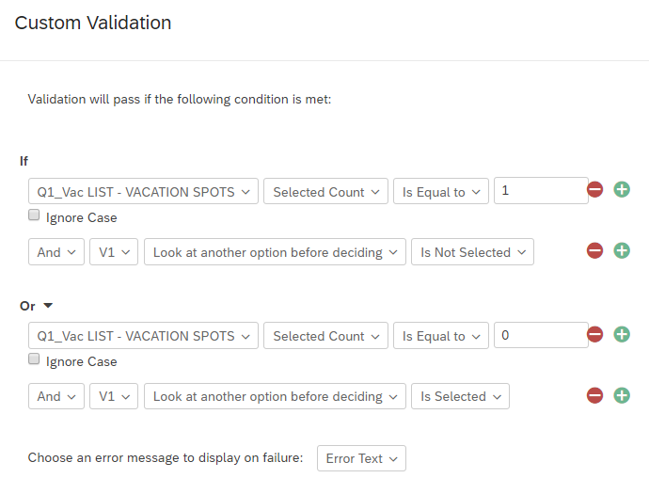

This entire process creates the first page of the sequential search setting. In a choice set with 15 options there should be 14 pages (2 options on the first page + 1 option per page in subsequent page), and each page should be programmed in relation to the previous one for the random drawing procedure to work properly. We will explain more about this below.
If the participant in our example (who saw “The Westin New York” and “Fiji Hideaway Resort & Spa”) decides to terminate search and choose one of the options, he/she will be directed to the next block in the survey (the block where manipulation checks and mediators should be located). If the participant decides to look at another option, the following is one possibility of what occurs (there are several possibilities depending on which vacation package is randomly drawn):
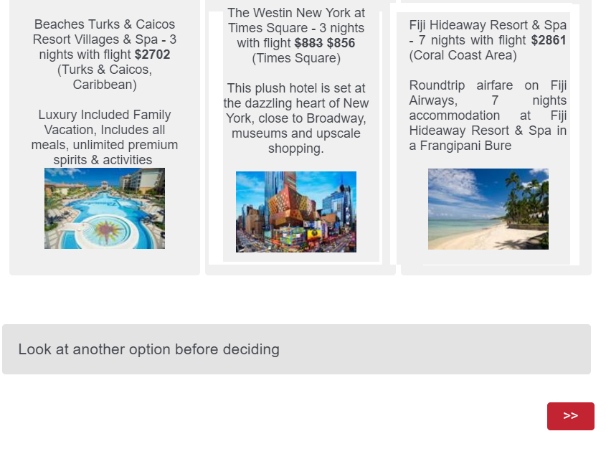
In this case, the “Beaches Turks & Caicos Resorts” was randomly drawn (without reposition) from the pool of options. That is: of the remaining 13 options (all vacation packages except for The Westin and Fiji Hideaway), one vacation package was randomly drawn. In addition to all specifications previously mentioned, there are several additional programming features that should be done for this to happen. Note that these are done on a separate page (after a page break), with two copies of the previous choice set and “look at another option” question.
First, the advanced randomization should be adjusted to randomly insert 1 option from the list (instead of two). This makes the survey insert only one option instead of two from the choice set. Second, the to-be-inserted randomly drawn option will come from the choice set question on the second page and should NOT include the previously displayed options (“The Westin” and “Fiji Hideway”). This is programmed by altering the “Display Logic” of each of the options (not the question) to “display the choice option only if the option was not displayed”. For example:
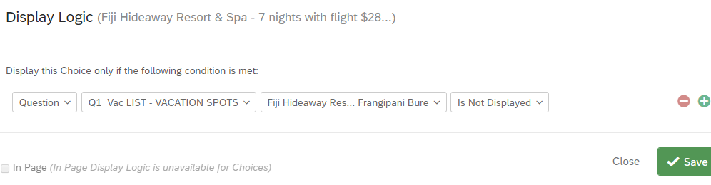
This display logic, when set in the page 2 choice set question, does the following: if Fiji Hideaway was displayed at page 1, then it should not be displayed as a random draw on page two. This prevents duplication of choice alternatives. This should be applied to every single option in the choice set: if the choice option appeared on the previous page, then it should not be displayed as a random draw on the current page.
Third, although we do not want the options to being duplicated, we want participants to be able to select the options that were displayed previously (i.e., we want to carry forward the displayed choices from page one to page two). To do this, the “carry forward choices” should be enabled in the choice set question (on page 2) such that the question will carry forward displayed choices from page 1.
These additional programming steps do the following: while maintaining the previously displayed two options, it randomly draws an additional option from the remaining options in the choice set (i.e., the options that were not already displayed).
Again, if the participant chooses one of the options, he/she is directed to the end of the block. If the participant decides to look at another option, the following page is displayed (in addition to the “look at another option” and arrow buttons:
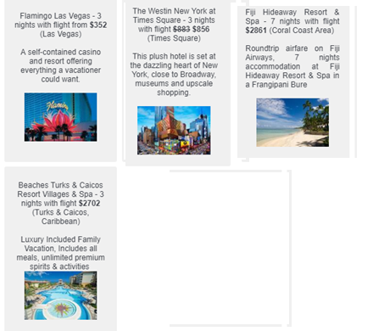
As discussed in the methodological detail appendix A, the order of the options that are displayed is in a column-major order array representation. The new (i.e., the recently randomly drawn options) are always the options that appear first. The third page (i.e., the page with four options) requires an extension of the programming that was done on the second page. Again, the choice set question should randomly insert one option out of the remaining options. Each of the options should have an additional layer of display logic such that each option can be displayed only if the option has not appeared both in pages one and two. Thus, for each of the options, the following display logic should be configured:
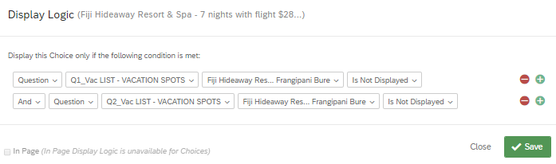
In addition, the choice set question on page 3 should carry forward choices displayed on page two. Setting up carry forward choices will bring both the two initial options from page 1 and the third option that appeared on page 2. Below is an example of a 5th page (6 options) from the participant’s perspective.

This requires the following display logic (for each of the options):
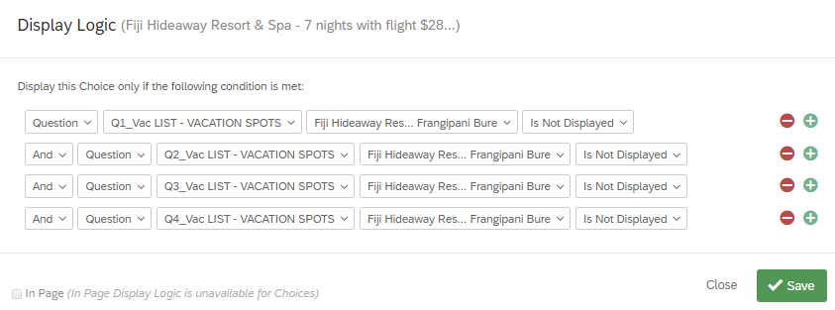
This goes on recursively, until page 14th. On page 14th, there is no “look at another option” variable. Rather, there is a “please select one of the options above” text. On this page, each of the options has a display logic that makes an option be able to be randomly selected only if this option has not appeared in any of the previously displayed pages.
When there are several options being displayed, the options do not show simultaneously on the screen. Such as e-commerce websites, the participant should scroll down (and up) to keep checking the pages. Hence, the larger the monitor/screen resolution, the more options the participant is able to see. We note that it is relatively easy for participants to change the zoom level while using internet browsers (e.g., Google chrome users can press Ctrl and use “+” or “-“ to increase or decrease the page magnification).
Finally, one may wonder how to process the data that is generated by Qualtrics to analyze the number of options considered, the choice of best option considered (which requires a ranking), the use of a satisficing (choice of the best option considered), the selected option, and the time spent per alternative. We will exemplify how to process the data using the vacation packages example (i.e., 15 options), but these methods can be extrapolated to any number of options (assuming one makes the necessary adjustments).
First, a timer question should be added on each page (e.g., right before the choice set questions). Next, it is important that the choice set, “look at another option”, and time variables are named and listed in a specific way. We suggest, and illustrate, using the following:
Choice set: named as “Qi_Vac”, with i being the number of the page. The first page (where 2 options are randomly drawn) should be Q1_Vac, the second page (with 3 options) should be Q3_Vac, and so on, until Q14_Vac (the page with 15 options). In addition, the values of each option should be recoded from 1 to 15. Hence, Fiji Hideaway would be 1, …, and Hilton San Diego Bayfront (the complete stimuli is available on this methodological detail appendix) would be 15.
Look at another option: named as Vi, with i being the number of page. There will be 13 variables (there is no option to look at another option at page 14). Example: V1, V2, …, V13. The value should be “1” if selected and 0 otherwise.
Time variables: similar logic to the “look at another option” one, but for all 14 pages, e.g., T1, …, T14.
To process the number of options considered, sum V1 to V13, and then add two. The logic is: each time the participant clicks “look at another option”, an additional option is revealed. However, the decision making process starts with the evaluation/comparison of two options. On SPSS, the syntax code would be:
COMPUTE DV=sum(V1,V2,V3,V4,V5,V6,V7,V8,V9,V10,V11,V12,V13)+2.
EXECUTE.
To process the time variables, sum from T1_Page_Submit to T14_Page_Submit. The code should be similar to the one used in the DV.
To process the selected option, one should merge the answers from Q1_Vac to Q14_Vac. The syntax code is:
DO IF DV = 2.
COMPUTE SelectedVacation=Q1_Vac.
ELSE IF DV=3.
COMPUTE SelectedVacation=Q2_Vac.
ELSE IF DV=4.
COMPUTE SelectedVacation=Q3_Vac.
ELSE IF DV=5.
COMPUTE SelectedVacation=Q4_Vac.
ELSE IF DV=6.
COMPUTE SelectedVacation=Q5_Vac.
ELSE IF DV=7.
COMPUTE SelectedVacation=Q6_Vac.
ELSE IF DV=8.
COMPUTE SelectedVacation=Q7_Vac.
ELSE IF DV=9.
COMPUTE SelectedVacation=Q8_Vac.
ELSE IF DV=10.
COMPUTE SelectedVacation=Q9_Vac.
ELSE IF DV=11.
COMPUTE SelectedVacation=Q10_Vac.
ELSE IF DV=12.
COMPUTE SelectedVacation=Q11_Vac.
ELSE IF DV=13.
COMPUTE SelectedVacation=Q12_Vac.
ELSE IF DV=14.
COMPUTE SelectedVacation=Q13_Vac.
ELSE IF DV=15.
COMPUTE SelectedVacation=Q14_Vac.
END IF.
Then, the “SelectedVacation” should be transformed to account for options that were selected based on a carry forward choices. When choices are carried forward within Qualtrics, they are coded in a different way. If there are 15 choices on page 1 (and they are coded from 1 to 15), and these choices are carried over from page 1 to page 2, these choices will have values from 16 to 30 (because 1 to 15 will be the codes associated with the options that can be potentially drawn from the choice set on page 2). In a similar vein, page 3 will have choices from 1 to 15 (the potentially drawn ones), 16 to 30 (the ones carried forward from the previous page – page 2), and 31 to 45 (the ones carried forward from page one to page two to page three). This keeps recursively increasing, generating a total of 210 codes for 15 unique choices/vacation packages. Note that 210 is 15 codes times 14 pages. To reorganize these values (that will be found in the SelectedVacation variable), run a recode on SPSS as follows. Note: this code assumes the choices were coded from 1 to 15 from the beginning.
RECODE SelectedVacation (16=1).
RECODE SelectedVacation (17=2).
RECODE SelectedVacation (18=3).
RECODE SelectedVacation (19=4).
RECODE SelectedVacation (20=5).
RECODE SelectedVacation (21=6).
RECODE SelectedVacation (22=7).
RECODE SelectedVacation (23=8).
RECODE SelectedVacation (24=9).
RECODE SelectedVacation (25=10).
RECODE SelectedVacation (26=11).
RECODE SelectedVacation (27=12).
RECODE SelectedVacation (28=13).
RECODE SelectedVacation (29=14).
RECODE SelectedVacation (30=15).
RECODE SelectedVacation (31=1).
RECODE SelectedVacation (32=2).
RECODE SelectedVacation (33=3).
… (we suggest using Microsoft Excel along with the concatenate function to easily expand this code. Please contact the first author for more information.)
RECODE SelectedVacation (208=13).
RECODE SelectedVacation (209=14).
RECODE SelectedVacation (210=15).

Next, we also suggest applying the value labels:
VALUE LABELS
SelectedVacation
1 'FijiHideaway'
2 'MaunaLani'
3 'HyattZilara'
4 'SheratonBungavilias'
5 'WaltDisney'
6 'HotelPalazzo'
7 'SAVOY'
8 'BeachesTurks'
9 'SheratonPuerto'
10 'FlamingoLasVegas'
11 'TheWestin'
12 'BlueLagoon'
13 'TheConfidante'
14 'Mystique'
15 'HiltonSanDiego'
Finally, for the choice of last option considered (satisficing) and choice of best option, a variety of approaches are available. These measures require downloading the “Display Order Data” from Qualtrics. They generate a variety of “display order” variables that show which options the participant saw, as well as the order of these options, for each page. The choice of last option considered is assessed by comparing the selected option with the option that is displayed as first on the last page participants saw before making a choice. For instance, if the participant made a choice once reaching page 7 (8 options), then the choice of this participant would have to be compared with all the display order variables of page 7, and the researcher should assess whether the display order variable with the number 1 is equal to the selected option. The choice of best option is assessed by making additional comparisons and collecting post-choice rankings of the options. First, one should use a procedure assessing participants’ preferences in such a way that one could acquire a ranking (e.g., from 1 to 15) of all the vacation packages. Then, by checking the options the participant saw/considered (i.e., by looking at the display orders of the last page saw by the participant), one could make an additional ranking (out of the options participant saw). If the participant has chosen the option with the lowest ranking number (i.e., the most preferred one), then this participant has chosen the best option in his or her consideration set.

APPENDIX F: ADDITIONAL METHODOLOGICAL DETAILS AND ANALYSES FOR EXPERIMENT 1
This methodological detail appendix contains information on the benefit goals pretest, manipulation checks for the decision process goals, choice shares, analyses of replicates and replicate positions, and decision time measures.

Benefit Goals Pretests
We conducted two pretests to select pairs of benefit goals that could be conflicting (and complementary) both for vacation packages and cars. This allowed us to use a common pair of benefit goals for two product categories in the same experiment. This pretest is relevant for experiments 1, 2, 3a, 3b, 4a, and 4b because they manipulate decision difficulty/ease using conflicting/complementary benefit goals.
Benefit Goals Pretests – Vacation Packages. In the vacation packages pretest, which was conducted in two separate samples (n = 75 undergraduate students, n = 55 MTurk participants), we asked participants:
Below are pairs of benefits people could look for when searching for a vacation package. We want to know how easy you think it would be to find both benefits in a vacation package. In other words, you should indicate how easy or hard it is to find a vacation package with both benefits at the same time. You will notice that some benefits are generally complementary (they can co-occur in several instances), whereas other benefits are generally conflicting (it is unlikely that they can co-occur).

The pretested pairs of benefits were: “economical and prestigious,” “economical and fun,” “economical and relaxing,” “economical and safe,” “prestigious and fun,” “prestigious and relaxing,” and “prestigious and safe.” For each pair, the scale used was (1 = Few vacation packages have both benefits, 9 = Many vacation packages have both benefits). Lower scores represent benefits perceived as conflicting, whereas higher scores represent benefits perceived as complementary.
In both samples, the “economical and prestigious” pair was perceived to be the most conflicting, whereas the “prestigious and fun” pair was perceived to be the most complementary. First, “economical and prestigious” had the lowest mean when compared to the other pairs. Second, t-tests found that the “economical and prestigious” score was significantly lower than all the other measured pair of benefits’ scores. The opposite pattern emerged with respect to the “prestigious and fun” pair. First, “prestigious and fun” had the highest mean when compared to the other pairs. Second, t-tests found that the “prestigious and fun” score was significantly higher than all the other measured pair of benefits’ scores.
Table MDA-F 1 presents the pretest results for the undergraduate student sample, whereas table MDA-F 2 presents the pretest results for the MTurk sample. Along with the means and standard deviations, the tables compare “economical and prestigious” with all the other pairs (4th column), and “prestigious and fun” with all the other pairs (5th column). In summary, this pretest shows that “prestige” and “economical” (“thrift” in main manuscript) are conflicting goals when people are searching for vacation packages, whereas “prestige” and “fun” are complementary goals.
TABLE MDA-F 1 (METHODOLOGICAL DETAIL APPENDIX F 1)
EXPERIMENTS 1 AND 2 – VACATION PACKAGES BENEFIT GOALS PRETEST UNDERGRADUATE STUDENT SAMPLE (n = 75)
Benefit Pair | Mean | SD | Comparison (Economical and Prestige vs. Others) | Comparison (Prestige and Fun vs. Others)
Economical and Prestigious | 3.28 | 2.85 | - | t(74) = 7.75, p < .001
Economical and Safe | 4.63 | 2.50 | t(74) = -2.90, p = .005 | t(74) = 5.27, p < .001
Prestigious and Safe | 4.77 | 2.49 | t(74) = -3.40, p = .001 | t(74) = 5.41, p < .001
Economical and Fun | 4.87 | 2.16 | t(74) = -4.15, p < .001 | t(74) = 5.31, p < .001
Economical and Relaxing | 5.05 | 2.51 | t(74) = -3.98, p < .001 | t(74) = 4.85, p < .001
Prestigious and Relaxing | 5.35 | 2.18 | t(74) = -4.73, p < .001 | t(74) = 4.06, p < .001
Prestigious and Fun | 6.96 | 2.43 | t(74) = -7.75, p < .001 | -

TABLE MDA-F 2 (METHODOLOGICAL DETAIL APPENDIX F 2)
EX EXPERIMENTS 1 AND 2 – VACATION PACKAGES BENEFIT GOALS PRETEST MTURK SAMPLE (n = 55)
Benefit Pair | Mean | SD | Comparison (Economical and Prestige vs. Others) | Comparison (Prestige and Fun vs. Others)
Economical and Prestigious | 4.18 | 2.45 | - | t(54) = 7.48, p < .001
Economical and Relaxing | 5.82 | 2.06 | t(54) = -4.00, p < .001 | t(54) = 5.05, p < .001
Economical and Fun | 5.84 | 2.18 | t(54) = -4.14, p < .001 | t(54) = 4.60, p < .001
Prestigious and Safe | 6.16 | 2.36 | t(54) = -4.99, p < .001 | t(54) = 3.48, p < .001
Economical and Safe | 6.24 | 2.04 | t(54) = -4.76, p < .001 | t(54) = 4.00, p < .001
Prestigious and Relaxing | 6.31 | 2.37 | t(54) = -4.79, p < .001 | t(54) = 3.18, p < .001
Prestigious and Fun | 7.33 | 1.53 | t(54) = -7.48, p < .001 | -

Benefit Goals Pretests – Cars. In the cars pretest, conducted in two separate samples (n = 75 undergraduate students, n = 55 MTurk participants), we asked participants:
Below are pairs of benefits people could look for when searching for a car. We want to know how easy you think it would be to find both benefits in a car. In other words, you should indicate how easy or hard it is to find a car with both benefits at the same time. You will notice that some benefits are generally complementary (they can co-occur in several instances), whereas other benefits are generally conflicting (it is unlikely that they can co-occur).

The pretested pairs of benefits were the same pairs used in the vacation packages pretest: “economical and prestigious,” “economical and fun,” “economical and relaxing,” “economical and safe,” “prestigious and fun,” “prestigious and relaxing,” and “prestigious and safe.” For each pair, the scale used was (1 = Few cars have both benefits, 9 = Many cars have both benefits). Lower scores represent benefits perceived as conflicting, whereas higher scores represent benefits perceived as complementary.
As in the vacation packages pretest, the “economical and prestigious” pair was perceived to be the most conflicting, whereas the “prestigious and fun” pair was perceived to be the most complementary. These results were consistent across both undergraduate student and MTurk samples. Therefore, we chose “prestige” and “economical” (“thrift” in main manuscript) as conflicting benefit goals for both vacation packages and cars. Moreover, “prestige” and “fun” were chosen as complementary goals for both product replicates. Tables MDA-F 3 and MDA-F 4 present results that are parallel to the vacation packages pretest.
TABLE MDA-F 3 (METHODOLOGICAL DETAIL APPENDIX F 3)
EXPERIMENTS 1 AND 2 – CARS BENEFIT GOALS PRETEST UNDERGRADUATE STUDENT SAMPLE (n = 75)
Benefit Pair | Mean | SD | Comparison (Economical and Prestige vs. Others) | Comparison (Prestige and Fun vs. Others)
Economical and prestigious | 3.37 | 2.78 | - | t(74) = 8.72, p < .001
Prestigious and safe | 4.79 | 2.43 | t(74) = -3.52, p = .001 | t(74) = 6.09, p < .001
Prestigious and relaxing | 5.03 | 2.42 | t(74) = -3.95, p < .001 | t(74) = 5.26, p < .001
Economical and safe | 5.03 | 2.53 | t(74) = -3.65, p < .001 | t(74) = 5.26, p < .001
Economical and fun | 5.08 | 2.38 | t(74) = -4.10, p < .001 | t(74) = 5.55, p < .001
Economical and relaxing | 6.03 | 2.69 | t(74) = -6.49, p < .001 | t(74) = 2.99, p = .004
Prestigious and fun | 7.25 | 2.33 | t(74) = -8.72, p < .001 | -

TABLE MDA-F 4 (METHODOLOGICAL DETAIL APPENDIX F 4)
EXPERIMENTS 1 AND 2 – CARS BENEFIT GOALS PRETEST
MTURK SAMPLE (n = 55)
Benefit Pair | Mean | SD | Comparison (Economical and Prestige vs. Others) | Comparison (Prestige and Fun vs. Others)
Economical and prestigious | 3.65 | 2.43 | - | t(54) = 8.49, p < .001
Economical and relaxing | 5.64 | 2.07 | t(54) = -5.12, p < .001 | t(54) = 3.25, p = .002
Economical and fun | 5.73 | 2.56 | t(54) = -5.47, p < .001 | t(54) = 2.44, p = .018
Prestigious and safe | 5.78 | 2.39 | t(54) = -4.39, p < .001 | t(54) = 3.30, p = .002
Economical and safe | 5.96 | 2.30 | t(54) = -4.33, p < .001 | t(54) = 2.83, p = .007
Prestigious and relaxing | 5.98 | 2.23 | t(54) = -5.09, p < .001 | t(54) = 2.81, p = .007
Prestigious and fun | 6.91 | 1.76 | t(54) = -8.49, p < .001 | -

Manipulation Check
Decision Process Goals. We measured the focus on maximizing accuracy (“During the [product category] choice task, how focused were you in being as accurate as possible in your choice?” 1 = not at all focused, 9 = very focused) and focus on minimizing effort (“During the [product category] choice task, how focused were you in putting in as less effort as possible in your choice?” 1 = not at all focused, 9 = very focused). We averaged the focus on maximizing accuracy (α = .87) and minimizing effort (α = .88) scores across replicates.
As expected, participants in the maximize accuracy condition were more focused on being accurate than participants in the minimize effort condition (M_{accuracy} = 7.43, SD_{accuracy} = 1.63; M_{effort} = 5.90, SD_{effort} = 2.40; F(1, 196) = 27.12, p < .001, $\hat{ω}$_{p}² = .12). There was no decision process goal by decision difficulty interaction (F(1, 196) = 1.57, p = .21). Also as expected, participants in the minimize effort condition were more focused on limiting effort than participants in the maximize accuracy condition (M_{accuracy} = 2.86, SD_{accuracy} = 1.91; M_{effort} = 5.17, SD_{effort} = 2.35; F(1, 196) = 59.21, p < .001, $\hat{ω}$_{p}² = .23). There was no decision process goal by decision difficulty interaction (F(1, 196) = 3.22, p = .074).
Decision Difficulty. Please see the methodological detail appendix H for more information on the decision difficulty manipulation check.

Choice Shares
The choice shares per condition for experiment 1 are presented in table MDA-F 5. The choice shares show that the options had a similar level of attractiveness, so that there were not objectively dominant or dominated options. A choice set with objectively dominant or dominated options could influence decision difficulty, and, in turn, the pursuit of decision process goals, introducing potential confounds. This happens because dominant or dominated options facilitate comparisons (i.e., it is easier to form evaluations), potentially reducing other manipulations of decision difficulty/ease. In fact, our choice sets in experiment 6 have dominant/dominated options because we use a decision difficulty operationalization that relies on such choice set characteristics (i.e., positive/negative correlation between attribute levels among options), suggesting that unless one wants to manipulate difficulty using a manipulation that is related to dominant/dominated options, the options should have a similar level of attractiveness.

TABLE MDA-F 5 (METHODOLOGICAL DETAIL APPENDIX F 5)
EXPERIMENT 1 – CHOICE SHARES PER CONDITION

Product Replicate Analyses
Experiment 1 included two product replicates: vacation packages and cars. The analyses collapsed across these replicates. The following are the tests for replicate interactions with other independent variables.
Product Replicates (number of options considered). There was no three-way interaction between product replicate, process goal, and decision difficulty (F(1, 196) = .97, p = .33), nor were there any second-order interactions between decision difficulty and product replicates (F(1, 196) = .40, p = .53) or the process goal and product replicates (F(1, 196) = 0.00, p = .99).
Product Replicate Position (number of options considered). There was no three-way interaction between product replicate position, process goal, and decision difficulty (F(1, 196) = .00, p = .95), nor were there any second-order interactions between decision difficulty and product replicate position (F(1, 196 = .79, p = .37) or the process goal and product replicate position (F(1, 196) = .10, p = .75).
Product Replicates (choice of best option considered). Given that participants who choose the best option for one product replicate need not do the same for the other product replicate, we tested for a product replicate interaction. We coded choice as: 0 = not the best option, 1 = best option. A generalized estimating equations (GEE) model, which is a generalized form of logistic regression for choices observed in a repeated measures design (Ge, Häubl, and Elrod 2011; Liang and Zeger 1986), showed no replicate by process goal by decision difficulty interaction (β = .06, Wald = .01, p = .94).
Product Replicate Position (choice of best option considered). Given that participants who choose the best option for the first product replicate need not do the same for the second product replicate, we tested for a product replicate position interaction. We coded choice as: 0 = not the best option, 1 = best option. A generalized estimating equations (GEE) model showed no replicate position by process goal by decision difficulty interaction (β = -.39, Wald = .25, p = .62).
Product Replicates (satisficing/choice of last option considered). Given that participants who satisfice for one product replicate need not do the same for the other product replicate, we tested for a product replicate interaction. We coded choice as: 0 = not the last option seen, 1 = last option seen. A generalized estimating equations (GEE) model showed no replicate by process goal by decision difficulty interaction (β = 1.26, Wald = .27, p = .60).
Product Replicate Position (satisficing/choice of last option considered). Given that participants who choose the best option for the first product replicate need not do the same for the second product replicate, we tested for a product replicate position interaction. We coded choice as: 0 = not the last option seen, 1 = last option seen. A generalized estimating equations (GEE) model showed no replicate position by process goal by decision difficulty interaction (β = -2.03, Wald = 3.18, p = .08).

Time Measures
An ANOVA revealed a replicate by process goal by decision difficulty interaction (F(1, 196) = 5.90, p = .02, ${\hat{ω}}_{p}^{2}$ = .02). This effect was unexpected. There was a process goal by decision difficulty interaction for both the vacation packages (F(1, 196) = 14.06, p < .001, ${\hat{ω}}_{p}^{2}$ = .06) and cars (F(1, 196) = 10.87, p = .001, ${\hat{ω}}_{p}^{2}$ = .05), and the pattern of results was the same for both replicates. Additional analyses revealed that participants spent more time during the vacation packages choice task (M = 51.55, SD = 47.12) than in the cars choice task (M = 34.17, SD = 27.57; F(1, 196) = 53.25, p < .001, ${\hat{ω}}_{p}^{2}$ = .21), and this has driven the three-way interaction. Because the pattern was the same across replicates, we collapsed for the further analyses. An ANOVA revealed a significant process goal by decision difficulty interaction (F(1, 196) = 15.29, p < .001,$\hat{ω}$_{p}² = .07). In the maximize accuracy goal condition, decision difficulty - conflicting benefit goals (M = 42.08, SD = 30.58) decreased the time spent on search relative to the baseline goal group (M = 60.92, SD = 43.79; F(1, 196) = 8.34, p = .004,$\hat{ω}$_{p}² = .06). In the minimize effort goal condition, decision difficulty - conflicting benefit goals (M = 43.74, SD = 30.44) increased the time spent on search relative to baseline goal group (M = 26.51, SD = 23.27; F(1, 196) = 6.98, p = .009,$\hat{ω}$_{p}² = .03). Finally, an ANOVA revealed no replicate position by process goal by decision difficulty interaction (F(1, 196) = 1.32, p = .25).

APPENDIX G: METHODOLOGICAL DETAILS AND ADDITIONAL analyses for experiment 2
This methodological detail appendix contains information on the decision process goal manipulation check, choice shares, analyses of replicates and replicate positions, and the time measures.

Manipulation Check
Decision Process Goals. We measured the focus on maximizing accuracy (“During the [product category] choice task, how focused were you in being as accurate as possible in your choice?” 1 = not at all focused, 9 = very focused) and focus on minimizing effort (“During the [product category] choice task, how focused were you in putting in as less effort as possible in your choice?” 1 = not at all focused, 9 = very focused).
We averaged the focus on maximizing accuracy (α = .78) and minimizing effort (α = .81) scores across replicates. As expected, participants in the maximize accuracy condition were more focused on being accurate than participants in the minimize effort condition (M_{accuracy} = 7.93, SD_{accuracy} = 1.13; M_{effort} = 6.95, SD_{effort} = 2.01; F(1, 442) = 39.99, p < .001, $\hat{ω}$_{p}² = .08). There was no decision process goal by decision ease interaction (F(1, 442) = 1.69, p = .19). As expected, participants in the minimize effort condition were more focused on limiting effort than participants in the maximize accuracy condition (M_{effort} = 6.41, SD_{effort} = 2.20; M_{accuracy} = 4.00, SD_{accuracy} = 2.80; F(1, 442) = 101.67, p < .001, $\hat{ω}$_{p}² = .19). There was no decision process goal by decision ease interaction (F(1, 442) = .16, p = .69).
Decision Difficulty. Please see the methodological detail appendix I for more information on the decision ease manipulation check.
Choice Shares.
The choice shares per condition for experiment 2 are presented in table MDA-G 1. The choice shares show that the options had a similar level of attractiveness, so that there were not objectively dominant or dominated options.
TABLE MDA-G 1 (METHODOLOGICAL DETAIL APPENDIX G – 1)
EXPERIMENT 2 – CHOICE SHARES PER CONDITION

Product Replicate Analyses
Product Replicates (number of options considered). There was no three-way interaction between product replicate, process goal, and decision ease (F(1, 442) = .295, p = .59), nor were there any second-order interactions between the decision ease and product replicates (F(1, 442 = 1.41, p = .24) or the process goal and product replicates (F(1, 442) = .62, p = .43).
Product Replicate Position (number of options considered). There was a three-way interaction between product replicate position, process goal, and decision ease (F(1, 442) = 7.65, p = .006, $\hat{ω}$_{p}² = .02). There were no second-order interactions between the decision ease and product replicate position (F(1, 442 = .005, p = .94) or the process goal and product replicate position (F(1, 442) = 2.55, p = .11). To further investigate the nature of this interaction, we performed separate ANOVAs on each product replicate position. The pattern for both product replicate positions was the same. That is, a separate analysis on each of the positions shows results consistent with H3.
For the replicate positioned as the first, an ANOVA revealed a significant decision process goal by decision ease interaction (F(1, 442) = 4.77, p = .029,$\hat{ω}$_{p}² = .01). To test if the pattern was consistent with H3, we assessed if the consideration of complementary benefit goals – decision ease - facilitated the pursuit of the process goals. In the maximize accuracy condition, decision ease - complementary benefit goals (M = 9.39, SD = 5.02) increased the number of options considered relative to the baseline goal control group (M = 8.37, SD = 5.40; F(1, 442) = 3.01, p = .084,$\hat{ω}$_{p}² = .01), but the effect was marginally significant. In the minimize effort condition, the direction of the means indicated that decision ease - complementary benefit goals (M = 3.59, SD = 3.16) decreased the number of options considered relative to the baseline goal control group (M = 4.39, SD = 4.39; F(1, 442) = 1.84, p = .18), but the effect was not significant. Therefore, it appears that the effect was weaker for the replicate positioned as the first.
For the replicate positioned as the second, an ANOVA revealed a significant decision process goal by decision ease interaction (F(1, 442) = 20.33, p < .001,$\hat{ω}$_{p}² = .042). To test if the pattern was consistent with H3, we assessed if the consideration of complementary benefit goals – decision ease - facilitated the pursuit of the process goals. In the maximize accuracy condition, decision ease - complementary benefit goals (M = 10.94, SD = 4.41) increased the number of options considered relative to the baseline goal control group (M = 8.92, SD = 5.57; F(1, 442) = 11.70, p = .001,$\hat{ω}$_{p}² = .02). In the minimize effort condition, decision ease - complementary benefit goals (M = 3.61, SD = 3.16) decreased the number of options considered relative to the baseline goal control group (M = 5.35, SD = 4.14; F(1, 442) = 8.74, p = .003,$\hat{ω}$_{p}² = .02).
Taken together, the findings suggest that the pattern predicted by H3 is present in both replicate positions. However, the effect was stronger for the replicate positioned as the second. Although speculations can be made (e.g., the floor effect implied by fig 3c., the effect of complementary goals in facilitating decision process goal pursuit is weaker than the effect of conflicting goals in inhibiting decision process goal pursuit), the interaction found does not change the pattern of results. Thus, we collapsed across replicates for the analyses in the main text.
Product Replicates (choice of best option considered). Given that participants who choose the best option for one product replicate need not do the same for the other product replicate, we tested for a product replicate interaction. We coded choice as: 0 = not the best option, 1 = best option. A generalized estimating equations (GEE) model, which is a generalized form of logistic regression for choices observed in a repeated measures design (Ge, Häubl, and Elrod 2011; Liang and Zeger 1986), showed no replicate by process goal by decision ease interaction (β = .22, Wald = .19, p = .66).
Product Replicate Position (choice of best option considered). Given that participants who choose the best option for the first product replicate need not do the same for the second product replicate, we tested for a product replicate position interaction. We coded choice as: 0 = not the best option, 1 = best option. A generalized estimating equations (GEE) model showed no replicate position by process goal by decision ease interaction (β = -.01, Wald = .000, p = .99).
Product Replicates (satisficing/choice of last option considered). Given that participants who satisfice for one product replicate need not do the same for the other product replicate, we tested for a product replicate interaction. We coded choice as: 0 = not the last option seen, 1 = last option seen. A generalized estimating equations (GEE) model showed no replicate by process goal by decision ease interaction (β = .31, Wald = .14, p = .71).
Product Replicate Position (satisficing/choice of last option considered). Given that participants who choose the best option for the first product replicate need not do the same for the second product replicate, we tested for a product replicate position interaction. We coded choice as: 0 = not the last option seen, 1 = last option seen. A generalized estimating equations (GEE) model showed no replicate position by process goal by decision ease interaction (β = -.05, Wald = .01, p = .95).

Time Measures
An ANOVA revealed no replicate by process goal by decision ease interaction (F(1, 442) = .23, p = .63) or a replicate position by process goal by decision ease interaction (F(1, 442) = 3.33, p = .07). An ANOVA revealed a significant process goal by decision ease interaction (F(1, 442) = 10.24, p = .001,$\hat{ω}$_{p}² = .02). In the maximize accuracy goal condition, decision ease - complementary benefit goals (M = 86.75, SD = 57.46) increased the time spent on search relative to the baseline goal group (M = 73.25, SD = 63.09; F(1, 442) = 4.45, p = .036,$\hat{ω}$_{p}² = .01). In the minimize effort goal condition, decision ease - complementary benefit goals (M = 25.83, SD = 23.32) decreased the time spent on search relative to baseline goal group (M = 41.30, SD = 36.21; F(1, 442) = 5.84, p = .016,$\hat{ω}$_{p}² = .10).

APPENDIX H: METHODOLOGICAL DETAILS AND ADDITIONAL ANALYSES FOR EXPERIMENTS 3A AND 3B
This methodological detail appendix contains information on the manipulation checks and the analyses of replicates alternative-explanation mediators.

Manipulation Check
Decision Difficulty (3a). Decision difficulty was measured by asking participants: “Please indicate your opinion about the car (vacation package) decision task” using a four-item, nine-point semantic differential scale: “very easy/very difficult,” “not problematic at all/very problematic,” “very simple/very complex,” “not complicated at all/very complicated” (α = .97; Laroche et al., 2005). There was a main effect of the decision difficulty manipulation on the decision difficulty measure (F(3, 192) = 24.84, p < .001, $\hat{ω}$_{p}² = .27). Participants in the difficult – two conflicting goals condition (M = 5.58, SD = 2.38) perceived the decision to be more difficult than participants in the two baseline - one goal conditions (M_{prestige} = 2.92, SD_{prestige} = 1.45; M_{thrift} = 3.31, SD_{thrift} = 1.60; (F(1, 192) = 64.85, p < .001) and baseline – no goal condition (M = 3.13, SD = 1.52; F(1, 192) = 48.09, p < .001). The two baseline – one goal conditions did not differ from each other (F(1, 192) = .1.18, p = .28), and these two conditions did not differ from the baseline – no goal condition (F(1, 192) = .002, p = .96). These results suggest that making a choice while considering conflicting benefit goals increases decision difficulty relative to when the choice is made while considering a single or a baseline/naturally activated baseline benefit goal.
Decision Difficulty (3b). We used the same items from experiment 3a to measure decision difficulty (α = .97). There was a main effect of the decision difficulty manipulation on the measure of decision difficulty (F(3, 200) = 10.55, p < .001, $\hat{ω}$_{p}² = .12). Participants in the difficult – two conflicting goals condition (M = 4.77, SD = 2.08) perceived the decision to be more difficult than participants in the baseline - one goal conditions (M_{prestige} = 3.17, SD_{prestige} = 1.70; M_{thrift} = 3.02, SD_{thrift} = 1.52; (F(1, 200) = 29.66, p < .001) and baseline – no goal condition (M = 3.28, SD = 1.73; F(1, 200) = 18.70, p < .001). The two baseline – one goal conditions did not differ from each other (F(1, 192) = .18, p = .67), and these two conditions did not differ from the baseline – no goal condition (F(1, 200) = .40, p = .53).
Product Replicates (3a). There was no product replicate by benefit goal interaction on the number of options considered (F(3, 192) = .753, p = .52), decision difficulty (F(3, 192) = .248, p = .86), decision uncertainty (F(3, 192) = 1.01, p = .39), process accountability (F(3, 192) = 1.23, p = .30), outcome accountability (F(3, 192) = 1.00, p = .39), involvement (F(3, 192) = 1.41, p = .24), and importance (F(3, 192) = .84, p = .47) measures. Thus, we collapsed across replicates for the analyses.
Product Replicates (3b). There was no product replicate by benefit goal interaction on the number of options considered (F(3, 200) = .38, p = .79), decision difficulty (F(3, 200) = 2.07, p = .105), decision uncertainty (F(3, 200) = 1.54, p = .21), process accountability (F(3, 200) = 261, p = .85), outcome accountability (F(3, 200) = 1.20, p = .31), involvement (F(3, 200) = .183, p = .91), and importance (F(3, 200) = .65, p = .59) measures. Thus, we collapsed across replicates for the analyses.

Alternative Explanations
Measures. Four additional alternative-hypothesis mediators were measured. Process accountability (α_{3a} = .69; α_{3b} = .81) and outcome accountability (α_{3a} = .73; α_{3b} = .81) were measured using four nine-point Likert items: “When making this decision, I concentrated on the process (outcome) of choosing,” “I believed that I would have to explain the process (outcome) of choosing to the researcher,” “I worried mostly about using (getting) the correct decision process (outcome), not about the final outcome (decision process),” “I was concerned mostly about using (getting) the correct decision process (outcome),” [1 = Strongly Disagree, 9 = Strongly Agree] (Zhang & Mittal, 2005). Decision importance was measured using a single semantic differential item (1 = not important at all, 9 = very important). Involvement in the choice task (α_{3a} = .96; α_{3b} = .97) was measured using three semantic differential items (1 = not involved at all, 9 = very involved; 1 = not interested at all, 9 = very interested; 1 = not engaged at all, 9 = very engaged) (Wilcox, Kramer, & Sen, 2011).
Alternative Explanations (3a). There was no effect of the benefit goal manipulation on outcome accountability (F(3, 192) = .54, p = .66), importance (F(3, 192) = .91, p = .44), and involvement (F(3, 192) = 2.46, p = .064). There was an unexpected effect on process accountability (F(3, 192) = 3.22, p = .024). Participants in the conflicting goals condition (M = 5.77, SD = 1.37) had higher levels of process accountability than participants in the baseline goal condition (M = 4.92, SD = 1.67; F(1, 192) = 8.56, p = .004). There were no differences in process accountability between the conflicting goals condition (M = 5.77) and one goal conditions (M_{prestige} = 5.50, SD_{prestige} = 1.38; M_{thrift} = 5.19, SD_{thrift} = 1.36; F(1, 192) = 2.87, p = .092). A mediation analysis showed process accountability did not mediate the influence of the planned contrast on the number of options considered (indirect effect 95% CI: -.09 to .04).
Alternative Explanations (3b). There was no effect of the benefit goal manipulation on process accountability (F(3, 200) = 1.40, p = .25), outcome accountability (F(3, 200) = .79, p = .501), and involvement (F(3, 200) = 2.30, p = .078). There was an unexpected effect on decision importance (F(3, 200) = 2.67, p = .048). Participants in the conflicting goals condition (M = 6.19, SD = 1.51) perceived the decision to be more important than participants in the one goal conditions (M_{prestige} = 5.72, SD_{prestige} = 2.40; M_{thrift} = 5.05, SD_{thrift} = 2.04; F(1, 200) = 4.94, p = .027). There were no differences in decision importance between the conflicting goals condition (M = 6.19) and baseline goal condition (M = 5.34, SD = 2.23; F(1, 200) = 3.46, p = .064). A mediation analysis with the two mediators, which allow a contrast between the two indirect effects, showed decision importance unexpectedly mediated the influence of the planned contrast on the number of options considered (95% CI: .01 to .10). A 95% confidence interval of the difference between decision uncertainty and decision importance mediators indicated the indirect effect of decision uncertainty (ab = -.14) was significantly stronger than the indirect effect of decision importance (ab = .01) [contrast CI: -.22 to -.09] (Hayes, 2013; Preacher & Hayes, 2008).

APPENDIX I: METHODOLOGICAL DETAILS AND ADDITIONAL ANALYSES FOR EXPERIMENTS 4A AND 4B
This methodological detail appendix contains information on the manipulation checks and on analyses of replicates alternative-explanation mediators.

Manipulation Check
Decision Ease (4a). We measured decision ease (α = .94) rather than decision difficulty (as in experiments 3a and 3b) by flipping the scale endpoints: “very difficult/very easy,” “very problematic/not problematic at all,” “very complex/very simple,” “very complicated/not complicated at all.” There was a main effect of the decision ease manipulation on the decision ease measure (F(3, 244) = 3.41, p = .018, $\hat{ω}$_{p}² = .03). Participants in the ease – two complementary goals condition (M = 7.21, SD = 1.38) perceived the decision to be easier than participants in the baseline - one goal conditions (M_{prestige} = 6.76, SD_{prestige} = 1.37; M_{fun} = 6.69, SD_{fun} = 1.34; F(1, 244) = 4.71, p = .031) or baseline – no goal condition (M = 6.39, SD = 1.65; F(1, 244) = 9.97, p = .002). The two baseline – one goal conditions did not differ from each other (F(1, 244) = .08, p = .78), and these two conditions did not differ from the baseline – no goal condition (F(1, 244) = 2.21, p = .14).
Decision Ease (4b). We used the same decision ease measures from experiment 4a (α = .94). here was a main effect of the decision ease manipulation on the decision ease measure (F(3, 416) = 5.27, p = .001, $\hat{ω}$_{p}² = .03). Participants in the ease – two complementary goals condition (M = 7.77, SD = 1.08) perceived the decision to be easier than participants in the baseline - one goal conditions (M_{prestige} = 7.06, SD_{prestige} = 1.50; M_{fun} = 7.24, SD_{fun} = 1.46; F(1, 416) = 14.47, p < .001) or baseline – no goal condition (M = 7.25, SD = 1.41; F(1, 416) = 7.62, p = .006). The two baseline – one goal conditions did not differ from each other (F(1, 244) = .84, p = .36), and these two conditions did not differ from the baseline – no goal condition(F(1, 416) = .34, p = .56).

Product Replicate Analyses
Product Replicates (4a). There was no product replicate by benefit goal interaction on the number of options considered (F(3, 244) = .20, p = .90), decision ease (F(3, 244) = .20, p = .90), decision certainty (F(3, 244) = .31, p = .82), process accountability (F(3, 244) = .30, p = .83), outcome accountability (F(3, 244) = 1.52, p = .21), involvement (F(3, 244) = .73, p = .54), and importance (F(3, 244) = .98, p = .40) measures. Thus, we collapsed across replicates for the analyses.
Product Replicates (4b). There was no product replicate by benefit goal interaction on the number of options considered (F(3, 416) = 1.00, p = .39), decision certainty (F(3, 416) = 1.91, p = .13), process accountability (F(3, 416) = .58, p = .63), outcome accountability (F(3, 416) = 1.37, p = .25), involvement (F(3, 416) = .191, p = .90), and importance (F(3, 416) = 1.38, p = .25) measures. There was an unexpected interaction on the decision ease measure (F(3, 416) = 4.20, p = .006). To further explore this interaction effect, we compared the decision ease for each of the replicates for each benefit goal condition. We found that for participants in the complementary goals condition, the decision was easier for cars (M = 8.00, SD = 1.21) than for vacation packages (M = 7.52, SD = 1.53; F(1, 416) = 6.18, p = .013). For participants in the baseline goal condition, the decision was easier for vacation packages (M = 7.48, SD = 1.57) than for cars (M = 7.01, SD = 1.98; F(1, 416) = 5.74, p = .017). There was no difference in decision ease across replicates for participants in the have fun (F(1, 416) = 1.19, p = .28) and prestige one goal conditions (F(1, 416) = .26, p = .61). Since this interaction does not change the interpretation of the results, we collapsed across replicates for the analyses.

Alternative Explanations
Measures. Four additional alternative-hypothesis mediators were measured. Process accountability (α_{4a} = .78; α_{4b} = .71) and outcome accountability (α_{4a} = .73; α_{4b} = .73) were measured using four nine-point Likert items: “When making this decision, I concentrated on the process (outcome) of choosing,” “I believed that I would have to explain the process (outcome) of choosing to the researcher,” “I worried mostly about using (getting) the correct decision process (outcome), not about the final outcome (decision process),” “I was concerned mostly about using (getting) the correct decision process (outcome),” [1 = Strongly Disagree, 9 = Strongly Agree] (Zhang & Mittal, 2005). Decision importance was measured using a single semantic differential item (1 = not important at all, 9 = very important). Involvement in the choice task (α_{4a} = .95; α_{4b} = .97) was measured using three semantic differential items (1 = not involved at all, 9 = very involved; 1 = not interested at all, 9 = very interested; 1 = not engaged at all, 9 = very engaged) (Wilcox, Kramer, & Sen, 2011).
Alternative Explanations (4a). There was no effect of the benefit goal manipulation on process accountability (F(3, 244) = 1.43, p = .24), outcome accountability (F(3, 244) = 1.44, p = .23), importance (F(3, 244) = .39, p = .76), and involvement (F(3, 244) = 1.95, p = .122).
Alternative Explanations (4b). There was no effect of the benefit goal manipulation on process accountability (F(3, 416 = 1.60, p = .19), outcome accountability (F(3, 416) = 2.45, p = .063), and importance (F(3, 416) = 2.08, p = .10). There was an unexpected effect on involvement (F(3, 416) = 4.59, p = .004). There were no differences in involvement between the complementary goals (M = 7.20, SD = 1.87) and one-goal conditions (M_{prestige} = 7.35, SD_{prestige} = 1.54; M_{fun} = 7.38, SD_{fun} = 1.50; F(1, 416) = .66, p = .42). However, involvement levels in the baseline goal condition (M = 6.58, SD = 2.13) were significantly lower than both the complementary goals (M = 7.20; F(1, 416) = 6.40, p = .012) and one-goal (M_{prestige} = 7.35, M_{fun} = 7.38; F(1, 416) = 13.54, p < .001) conditions. A mediation analysis showed involvement did not mediate the influence of the planned contrast on the number of options considered (indirect effect 95% CI: -.01 to .02).

APPENDIX J: METHODOLOGICAL DETAILS AND ADDITIONAL ANALYSES FOR EXPERIMENT 5
This methodological detail appendix contains information on the manipulation checks for the decision process goals and decision difficulty, choice shares, and the time measures.

Manipulation Check
Decision Process Goal (maximize accuracy). We measured the focus on maximizing accuracy (“During the movie choice task, how focused were you in being as accurate as possible in your choice?” 1 = not at all focused, 9 = very focused). There was a main effect of the decision process goal manipulation on the maximize accuracy focus measure (F(2, 531) = 31.77, p < .001,$\hat{ω}$_{p}² = .10). As expected, participants in the maximize accuracy condition (M = 7.51, SD = 1.87) were more focused on being accurate than participants in the baseline process goal (M = 6.64, SD = 2.20; F(1, 531) = 14.22, p < .001,$\hat{ω}$_{p}² = .02) and minimize effort process goal conditions (M = 5.67, SD = 2.46; F(1, 531) = 63.48, p < .001,$\hat{ω}$_{p}² = .11). In addition, participants in the baseline process goal condition were more focused on being accurate than participants in the minimize effort process goal condition (F(1, 531) = 17.61, p < .001,$\hat{ω}$_{p}² = .03). There was no main effect of decision difficulty (F(2, 531) = .77, p = .87) or interaction (F(4, 531) = .31, p = .87). Thus, people became more focused on being accurate when a maximize accuracy goal was active than when no decision process goal or a minimize effort process goal was active.
Decision Process Goal (minimize effort). We measured the focus on minimizing effort (“During the movie choice task, how focused were you in putting in as less effort as possible in your choice?” 1 = not at all focused, 9 = very focused). There was a main effect of the decision process goal manipulation on the minimize effort focus measure (F(2, 531) = 38.38, p < .001,$\hat{ω}$_{p}² = .12). As expected, participants in the minimize effort condition (M = 6.94, SD = 2.15) were more focused on minimizing effort than participants in the baseline process goal (M = 4.66, SD = 2.86; F(1, 531) = 64.41, p < .001,$\hat{ω}$_{p}² = .11) and maximize accuracy process goal conditions (M = 4.94, SD = 3.00; F(1, 531) = 49.79, p < .001,$\hat{ω}$_{p}² = .08). There was no difference between participants in the baseline process goal and maximize accuracy process goal conditions (F(1, 531) = .94, p = .33). There was no main effect of decision difficulty (F(2, 531) = .47, p = .63) or interaction (F(4, 531) = 1.64, p = .16). Thus, people became more focused on minimizing effort when a minimize effort goal was active than when no decision process goal or a maximize accuracy goal was active.
Decision Difficulty. As in the previous experiments, decision difficulty was measured by asking participants: “Please indicate your opinion about the car (vacation package) decision task” using a four-item, nine-point semantic differential scale: “very easy/very difficult,” “not problematic at all/very problematic,” “very simple/very complex,” “not complicated at all/very complicated” (α = .91; Laroche et al., 2005). There was a main effect of the decision difficulty manipulation on the decision difficulty measure (F(2, 531) = 84.35, p < .001,$\hat{ω}$_{p}² = .24). Participants in the difficult condition (M = 5.69, SD = 2.08) perceived the decision to be more difficult than participants in the moderate (M = 3.93, SD = 2.19; F(1, 531) = 69.19, p < .001,$\hat{ω}$_{p}² = .11) and easy (M = 3.00, SD = 1.67; F(1, 531) = 164.05, p < .001,$\hat{ω}$_{p}² = .23) conditions. In addition, participants in the moderate condition perceived the decision to be more difficult than participants in the easy condition (F(1, 531) = 20.07, p < .001,$\hat{ω}$_{p}² = .04). There was no main effect of process goal (F(2, 531) = .79, p = .45) or interaction (F(4, 531) = 1.19, p = .32). Thus, the larger the amount of information, the more difficult the decision was perceived to be.
Process Goal Abandonment. To assess decision process goal abandonment, we asked participants: “To what extent were you trying to maximize accuracy (minimize effort) during the movie search process?” (1 = not at all, 9 = very much), and “To what extent did you give up on maximizing accuracy (minimizing effort) during the movie search process?” (1 = not at all, 9 = very much).
There was no interaction between process goal and decision difficulty on perceptions of maximize accuracy pursuit during search (F(4, 531) = .451, p = .77). There was no main effect of decision difficulty (F(2, 531) = .016, p = .98). There was a main effect of process goal (F(2, 531) = 83.19, p < .001; ${\hat{ω}}_{p}^{2}$ = .24) such that participants in the maximize accuracy condition (M = 7.27, SD = 1.80) reported trying to maximize accuracy to a greater extent than participants in the baseline (M = 5.88, SD = 1.99; F(1, 531) = 39.84, p < .001; ${\hat{ω}}_{p}^{2}$ = .07) and minimize effort (M = 4.42, SD = 2.42; F(1, 531) = 166.36, p < .001; ${\hat{ω}}_{p}^{2}$ = .24) conditions.
There was no interaction between process goal and decision difficulty on perceptions of minimize effort pursuit during search (F(4, 531) = 1.49, p = .21). There was no main effect of decision difficulty (F(2, 531) = .309, p = .74). There was a main effect of process goal (F(2, 531) = 51.02, p < .001; ${\hat{ω}}_{p}^{2}$ = .02) such that participants in minimize effort condition (M = 6.64, SD = 2.34) reported trying to minimize effort to a greater extent than participants in the baseline (M = 4.14, SD = 2.58; F(1, 531) = 83.82, p < .001; ${\hat{ω}}_{p}^{2}$ = .01) and maximize accuracy (M = 4.38, SD = 2.81; F(1, 531) = 68.64, p < .001; ${\hat{ω}}_{p}^{2}$ = .01) conditions.
There was no interaction between process goal and decision difficulty on perceptions of maximize accuracy abandonment (F(4, 531) = 1.06, p = .38). There was no main effect of decision difficulty (F(2, 531) = 1.59, p = .21). There was a main effect of process goal (F(2, 531) = 19.79, p < .001; ${\hat{ω}}_{p}^{2}$ = .07) such that participants in the minimize effort condition (M = 6.06, SD = 2.42) reported giving up on maximize accuracy to a greater extent than participants in the baseline (M = 4.66, SD = 2.82; F(1, 531) = 24.88, p < .001; ${\hat{ω}}_{p}^{2}$ = .04) and maximize accuracy (M = 4.43, SD = 2.74; F(1, 531) = 33.80, p < .001; ${\hat{ω}}_{p}^{2}$ = .06) conditions.
There was no interaction between process goal and decision difficulty on perceptions of maximize accuracy abandonment (F(4, 531) = .744, p = .56). There was no main effect of decision difficulty (F(2, 531) = 2.10, p = .12) or process goal (F(2, 531) = .91, p = .41).

Choice Shares
The choice shares per condition for experiment 5 are presented in table MDA-G 1. The choice shares show that the options had a similar level of attractiveness, so that there were not objectively dominant or dominated options.
TABLE MDA-J 1 (METHODOLOGICAL DETAIL APPENDIX J – 1)
EXPERIMENT 5 – CHOICE SHARES PER CONDITION
 | Maximize Accuracy
 | Small | Moderate | Large
Mission Impossible | 13.3% | 11.7% | 16.7%
Fast Color | 5.0% | 3.3% | 3.3%
The Good Guy | 0.0% | 3.3% | 8.3%
All Square | 5.0% | 3.3% | 0.0%
High-Rise | 1.7% | 0.0% | 3.3%
What Men Want | 5.0% | 1.7% | 6.7%
Fighting With My Family | 5.0% | 0.0% | 1.7%
The Commuter | 6.7% | 3.3% | 6.7%
Arbitrage | 1.7% | 5.0% | 1.7%
Dog Days | 5.0% | 8.3% | 0.0%
The Prince | 1.7% | 3.3% | 3.3%
I Kill Giants | 1.7% | 5.0% | 5.0%
Along With the Gods The Two Worlds | 6.7% | 3.3% | 5.0%
The Sisters Brothers | 1.7% | 5.0% | 5.0%
Changeland | 0.0% | 6.7% | 1.7%
Running With the Devil | 1.7% | 3.3% | 1.7%
The Lincoln Lawyer | 11.7% | 1.7% | 6.7%
Leap Year | 5.0% | 3.3% | 5.0%
And So It Goes | 6.7% | 1.7% | 3.3%
Backtrace | 0% | 0% | 0%
Daylights End | 1.7% | 3.3% | 5.0%
Under the Tree | 1.7% | 6.7% | 1.7%
The Osiris Child | 5.0% | 1.7% | 3.3%
The Colony | 1.7% | 5.0% | 3.3%
Black Rock | 5.0% | 10.0% | 1.7%
 | Baseline
 | Small | Moderate | Large
Mission Impossible | 13.9% | 4.9% | 11.7%
Fast Color | 3.9% | 3.3% | 5.0%
The Good Guy | 3.9% | 8.2% | 8.3%
All Square | 2.8% | 3.3% | 0.0%
High-Rise | 1.7% | 1.6% | 1.7%
What Men Want | 4.4% | 3.3% | 1.7%
Fighting With My Family | 2.2% | 4.9% | 1.7%
The Commuter | 5.6% | 0.0% | 10.0%
Arbitrage | 2.8% | 9.8% | 3.3%
Dog Days | 4.4% | 4.9% | 3.3%
The Prince | 2.8% | 1.6% | 1.7%
I Kill Giants | 3.9% | 1.6% | 1.7%
Along With the Gods: The Two Worlds | 5.0% | 4.9% | 8.3%
The Sisters Brothers | 3.9% | 1.6% | 11.7%
Changeland | 2.8% | 6.6% | 5.0%
Running With the Devil | 2.2% | 3.3% | 5.0%
The Lincoln Lawyer | 6.7% | 3.3% | 3.3%
Leap Year | 4.4% | 6.6% | 1.7%
And So It Goes | 3.9% | 3.3% | 3.3%
Backtrace | 0% | 1.6% | 0.0%
Daylights End | 3.3% | 4.9% | 5.0%
Under the Tree | 3.3% | 1.6% | 1.7%
The Osiris Child | 3.3% | 8.2% | 3.3%
The Colony | 3.3% | 3.3% | 0.0%
Black Rock | 5.6% | 3.3% | 1.7%
 | Minimize Effort
 | Small | Moderate | Large
Mission Impossible | 6.8% | 7.8% | 11.5%
Fast Color | 3.4% | 3.9% | 1.6%
The Good Guy | 1.7% | 6.1% | 0.0%
All Square | 0.0% | 1.1% | 6.6%
High-Rise | 8.5% | 3.9% | 1.6%
What Men Want | 3.4% | 2.8% | 1.6%
Fighting With My Family | 6.8% | 4.4% | 3.3%
The Commuter | 3.4% | 4.4% | 3.3%
Arbitrage | 1.7% | 5.0% | 1.6%
Dog Days | 5.1% | 4.4% | 3.3%
The Prince | 3.4% | 2.2% | 1.6%
I Kill Giants | 5.1% | 2.8% | 3.3%
Along With the Gods: The Two Worlds | 0.0% | 4.4% | 0.0%
The Sisters Brothers | 1.7% | 5.0% | 9.8%
Changeland | 8.5% | 6.7% | 1.6%
Running With the Devil | 1.7% | 3.3% | 6.6%
The Lincoln Lawyer | 1.7% | 2.8% | 6.6%
Leap Year | 3.4% | 3.9% | 4.9%
And So It Goes | 6.8% | 4.4% | 4.9%
Backtrace | 3.4% | 1.7% | 3.3%
Daylights End | 6.8% | 5.6% | 1.6%
Under the Tree | 1.7% | 1.7% | 6.6%
The Osiris Child | 5.1% | 5.6% | 6.6%
The Colony | 6.8% | 3.3% | 3.3%
Black Rock | 3.4% | 2.8% | 4.9%

Time Measures
An ANOVA revealed a significant interaction (F(4, 531) = 16.41, p < .001,$\hat{ω}$_{p}² = .09). The patterns are similar to those observed on the number of options considered. Participants in the maximize accuracy - difficult condition (M = 67.75, SD = 74.31) spent less time during search than participants in the moderate condition (M = 100.57, SD = 83.99; F(1, 531) = 7.25, p = .007,$\hat{ω}$_{p}² = .01). The difference between participants in the maximize accuracy – easy condition (M = 118.97, SD = 77.54) and participants in the moderate condition was directional, but not significant (F(1, 531) = 2.28, p = .13).
The difference between participants in the baseline process goal - difficult condition (M = 47.87, SD = 43.12) and participants in the moderate condition was directional, but not significant (M = 67.52, SD = 76.30; F(1, 531) = 2.58, p = .11). Participants in the baseline process goal – easy condition (M = 95.07, SD = 78.57) spent more time on search than participants in the moderate condition was significant (F(1, 531) = 5.15, p = .024, ${\hat{ω}}_{p}^{2}$ = .01).
Participants in the minimize effort - difficult condition (M = 89.39, SD = 63.39) spent less time during search than participants in the moderate condition (M = 61.63, SD = 53.57; F(1, 531) = 5.14, p = .024,$\hat{ω}$_{p}² = .01). Participants in the minimize effort – easy condition (M = 28.17, SD = 27.81) spent more time on search than participants in the moderate condition was significant (F(1, 531) = 7.59, p = .006,$\hat{ω}$_{p}² = .01).

APPENDIX K: METHODOLOGICAL DETAILS AND ADDITIONAL ANALYSES FOR EXPERIMENT 6
This methodological detail appendix contains information on the process goal accessibility prime manipulation, manipulation checks for the decision process goals and decision difficulty, and time measures.

Process Goal Accessibility Prime Manipulations
8 Options – Effort/Accuracy Trade-Off Not Salient. “Imagine you are scrolling through your preferred movie streaming service searching for a movie to watch. We want you to make a choice among 8 movies. You will enter a random drawing for a 1/100 chance of winning a gift card to watch this movie (we will contact winners after data collection is finished via the bonus payment feature). Hence, please choose as you would do in a real life situation. We encourage you to search for additional information about the movies (using a new tab) if you want. Please take your time!”
50 Options – Effort/Accuracy Trade-Off Salient. “Imagine you are scrolling through your preferred movie streaming service searching for a movie to watch. We want you to make a choice among 50 movies. You will enter a random drawing for a 1/100 chance of winning a gift card to watch this movie (we will contact winners after data collection is finished via the bonus payment feature). Hence, please choose as you would do in a real life situation. We encourage you to search for additional information about the movies (using a new tab) if you want. Please take your time!”

Stimuli for Process Goal Accessibility Prime Manipulations
Below are the 50 movies. Participants in the trade-off not salient condition saw 8 options (randomly drawn) from the 50 movies. Participants in the trade-off salient condition saw the 50 options. All participants had to choose one of the options. The options were displayed in 8 columns and in random order. The options are resized in the methodological web appendix for conciseness.
 |  |  |  | 
 |  |  |  | 
 | 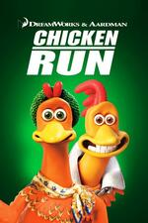 |  |  | 
 |  |  |  | 
 |  |  |  | 
 |  |  |  | 
 |  |  |  | 
 |  |  |  | 
 |  |  |  | 
 |  |  |  | 

Manipulation Check
Decision Difficulty. Decision difficulty was measured by asking participants: “Please indicate your opinion about the laptop decision task” using a four-item, nine-point semantic differential scale: “very easy/very difficult,” “not problematic at all/very problematic,” “very simple/very complex,” “not complicated at all/very complicated” (α = .95). There was a main effect of the decision difficulty manipulation on the decision difficulty measure (F(1, 588) = 94.72, p < .001, $\hat{ω}$_{p}² = .14), such that participants in the difficult condition (M = 4.67, SD = 2.47) perceived the decision to be more difficult than participants in the easy condition (M = 2.83, SD = 2.14). There was no main effect of process goal accessibility prime (F(1, 588) = .001, p = .98) or decision process goal (F(2, 588) = 1.66, p = .19). These results indicate that the negative correlation made the decision more difficult.
Decision Process Goal (maximize accuracy). We measured focus on maximizing accuracy (“During the [product category] choice task, how focused were you in being as accurate as possible in your choice?” 1 = not at all focused, 9 = very focused). There was a main effect of the decision process goal manipulation on the maximize accuracy measure (F(2, 588) = 93.12, p < .001, $\hat{ω}$_{p}² = .24). Participants in the maximize accuracy condition (M = 8.10, SD = 1.14) were more focused on being accurate than participants in the baseline process goal (M = 6.24, SD = 2.56; F(1, 588) = 67.14, p < .001, $\hat{ω}$_{p}² = .10) and minimize effort process goal conditions (M = 5.02, SD = 2.76; F(1, 588) = 184.10, p < .001, $\hat{ω}$_{p}² = .24). Participants in the baseline process goal condition were more focused on being accurate than participants in the minimize effort process goal condition (F(1, 588) = 28.88, p < .001, $\hat{ω}$_{p}² = .05). There was no main effect of decision difficulty (F(1, 588) = .105, p = .75) or process goal accessibility prime (F(1, 588) = 1.49, p = .22). Thus, people become more focused on being accurate when a maximize accuracy goal was active than when no decision process goal or a minimize effort process goal was active.
Decision Process Goal (minimize effort). We measured focus on minimizing effort (“During the [product category] choice task, how focused were you in putting in as less effort as possible in your choice?” 1 = not at all focused, 9 = very focused). There was a main effect of the decision process goal manipulation on the minimize effort measure (F(2, 588) = 55.36, p < .001, $\hat{ω}$_{p}² = .16). Participants in the minimize effort condition (M = 6.66, SD = 2.22) were more focused on minimizing effort than participants in the baseline process goal (M = 4.81, SD = 2.87; F(1, 588) = 47.75, p < .001, $\hat{ω}$_{p}² = .07) and maximize accuracy process goal conditions (M = 3.90, SD = 2.91; F(1, 588) = 106.86, p < .001, $\hat{ω}$_{p}² = .15). Participants in the maximize accuracy condition were less focused on minimizing effort than participants in the baseline decision process goal condition (F(1, 588) = 11.74, p = .001, $\hat{ω}$_{p}² = .02). There was no main effect of decision difficulty (F(1, 588) = .706, p = .40). There was a main effect of process goal accessibility prime (F(1, 588) = 4.91, p = .03) such that participants in the trade-off salient condition (M = 5.37, SD = 2.92) were more focused on minimizing effort than participants in trade-off not salient condition (M = 4.88, SD = 2.90). This effect was expected, as a more difficult decision should encourage a desire to minimize effort. Thus, people become more focused on minimizing effort when a minimize effort goal was active than when no decision process goal or a maximize accuracy goal was active.
Effort-Accuracy Trade-Off Focus. We measured the extent to which participants focused on the effort-accuracy tradeoff during search (α = .78) using three items: “To which extent did try to balance between maximizing accuracy and minimizing effort during the laptop search process?”, “To which extent did you focus on the trade-off between maximizing accuracy and minimizing effort during the laptop search process?”, and “To which extent did you consider the trade-off between searching for the best option available and searching for an option that was good enough?” (1 = not at all, 9 = very much).
There was a main effect of the process goal accessibility manipulation on the trade-off measure (F(1, 588) = 98.48, p < .001, $\hat{ω}$_{p}² = .14), such that participants in the trade-off salient condition (M = 6.29, SD = 1.98) were more focused on the effort-accuracy trade-off during the choice task than participants in the trade-off not salient condition (M = 4.88, SD = 1.54). This indicated that the process goal accessibility manipulation was successful. As expected, there was also a main effect of the decision process goal manipulation on the trade-off measure (F(2, 588) = 16.72, p < .001, $\hat{ω}$_{p}² = .05), such that participants in the baseline decision process goal (M = 6.15, SD = 1.64) were more focused on the effort-accuracy trade-off than participants in the maximize accuracy (M = 5.21, SD = 1.97; F(1, 588) = 29.96, p < .001, $\hat{ω}$_{p}² = .09) and minimize effort (M = 5.40, SD = 1.96; F(1, 588) = 19.15, p < .001, $\hat{ω}$_{p}² = .06) conditions. This indicated that people without a deliberately manipulated decision process goal naturally considered the effort/accuracy trade-off. There was no main effect of decision difficulty (F(1, 588) = .16, p = .69).
Process Goal Abandonment. To assess decision process goal abandonment, we asked participants: “To what extent were you trying to maximize accuracy (minimize effort) during the movie search process?” (1 = not at all, 9 = very much), and “To what extent did you give up on maximizing accuracy (minimizing effort) during the movie search process?” (1 = not at all, 9 = very much).
There was no process goal accessibility prime by process goal by decision difficulty interaction on perceptions of maximize accuracy pursuit during search (F(2, 588) = 1.96, p = .14). There was no decision difficulty by process goal accessibility prime interaction (F(1, 588) = .079, p = .78). There was no decision difficulty by process goal interaction (F(2, 588) = 1.10, p = .34). There was no main effect of decision difficulty (F(1, 588) = .60, p = .44).
There was no process goal accessibility prime by process goal by decision difficulty interaction on perceptions of minimize effort pursuit during search (F(2, 588) = .23, p = .79). There was no decision difficulty by process goal accessibility prime interaction (F(1, 588) = .29, p = .59). There was no decision difficulty by process goal interaction (F(2, 588) = .04, p = .96). There was no main effect of decision difficulty (F(1, 588) = 1.13, p = .29).
There was no process goal accessibility prime by process goal by decision difficulty interaction on perceptions of maximize accuracy abandonment (F(2, 588) = .67, p = .51). There was no decision difficulty by process goal accessibility prime interaction (F(1, 588) = 1.83, p = .18). There was no decision difficulty by process goal interaction (F(2, 588) = 1.48, p = .23). There was no main effect of decision difficulty (F(1, 588) = 2.10, p = .15).
There was no process goal accessibility prime by process goal by decision difficulty interaction on perceptions of minimize effort abandonment (F(2, 588) = .38, p = .68). There was no decision difficulty by process goal accessibility prime interaction (F(1, 588) = 2.06, p = .15). There was no decision difficulty by process goal interaction (F(2, 588) = 1.56, p = .21). There was no main effect of decision difficulty (F(1, 588) = 2.24, p = .14).

Choice Shares
We note that the laptop options are listed from dominated to dominant options in the ease columns. Thus, although participants do not necessarily see all the options, the higher shares indicate that these options are more likely to be chosen (provided they appear).
 |  | Trade-Off Not Salient
 |  | Maximize Accuracy |  |  |  | Baseline (No Goal) |  |  |  | Minimize Effort
 |  | Ease |  | Difficulty |  | Ease |  | Difficulty |  | Ease |  | Difficulty
UTZ |  | 0.0% |  | 14.0% |  | 2.0% |  | 16.0% |  | 4.0% |  | 14.0%
MPS |  | 2.0% |  | 0.0% |  | 0.0% |  | 8.0% |  | 4.0% |  | 6.0%
YZZ |  | 2.0% |  | 0.0% |  | 2.0% |  | 4.0% |  | 2.0% |  | 12.0%
NPS |  | 2.0% |  | 0.0% |  | 2.0% |  | 8.0% |  | 2.0% |  | 2.0%
MGS |  | 4.0% |  | 10.0% |  | 2.0% |  | 0.0% |  | 0.0% |  | 2.0%
HPE |  | 0.0% |  | 2.0% |  | 0.0% |  | 12.0% |  | 6.0% |  | 2.0%
YMM |  | 2.0% |  | 4.0% |  | 0.0% |  | 2.0% |  | 0.0% |  | 2.0%
XPT |  | 2.0% |  | 18.0% |  | 2.0% |  | 6.0% |  | 2.0% |  | 12.0%
XPX |  | 8.0% |  | 6.0% |  | 2.0% |  | 2.0% |  | 12.0% |  | 6.0%
YZP |  | 4.0% |  | 6.0% |  | 14.0% |  | 14.0% |  | 10.0% |  | 12.0%
NPP |  | 6.0% |  | 2.0% |  | 10.0% |  | 10.0% |  | 0.0% |  | 2.0%
UXT |  | 6.0% |  | 10.0% |  | 8.0% |  | 4.0% |  | 4.0% |  | 4.0%
MPE |  | 8.0% |  | 4.0% |  | 16.0% |  | 0.0% |  | 16.0% |  | 10.0%
UZS |  | 22.0% |  | 18.0% |  | 12.0% |  | 8.0% |  | 10.0% |  | 12.0%
MPX |  | 32.0% |  | 6.0% |  | 28.0% |  | 6.0% |  | 28.0% |  | 2.0%
 | Trade-Off Salient
 | Maximize Accuracy |  |  |  | Baseline (No Goal) |  |  |  | Minimize Effort
 | Ease |  | Difficulty |  | Ease |  | Difficulty |  | Ease |  | Difficulty
UTZ | 2.0% |  | 22.0% |  | 4.0% |  | 4.0% |  | 2.0% |  | 13.0%
MPS | 2.0% |  | 4.0% |  | 2.0% |  | 8.0% |  | 0.0% |  | 4.3%
YZZ | 2.0% |  | 6.0% |  | 4.0% |  | 6.0% |  | 4.0% |  | 5.0%
NPS | 0.0% |  | 8.0% |  | 0.0% |  | 4.0% |  | 2.0% |  | 5.3%
MGS | 6.0% |  | 4.0% |  | 2.0% |  | 2.0% |  | 4.0% |  | 4.0%
HPE | 2.0% |  | 10.0% |  | 8.0% |  | 8.0% |  | 6.0% |  | 6.7%
YMM | 4.0% |  | 6.0% |  | 0.0% |  | 4.0% |  | 4.0% |  | 4.0%
XPT | 6.0% |  | 8.0% |  | 4.0% |  | 12.0% |  | 6.0% |  | 10.7%
XPX | 2.0% |  | 4.0% |  | 6.0% |  | 8.0% |  | 4.0% |  | 5.7%
YZP | 6.0% |  | 6.0% |  | 6.0% |  | 10.0% |  | 8.0% |  | 10.0%
NPP | 10.0% |  | 6.0% |  | 14.0% |  | 8.0% |  | 0.0% |  | 6.0%
UXT | 6.0% |  | 4.0% |  | 4.0% |  | 4.0% |  | 6.0% |  | 5.3%
MPE | 2.0% |  | 4.0% |  | 10.0% |  | 10.0% |  | 12.0% |  | 6.0%
UZS | 14.0% |  | 6.0% |  | 12.0% |  | 8.0% |  | 22.0% |  | 10.3%
MPX | 36.0% |  | 2.0% |  | 24.0% |  | 4.0% |  | 20.0% |  | 3.7%

Time Measures
There was no three-way interaction between process goal accessibility prime, decision difficulty, and decision process goal (F(2, 588) = .184, p = .83). Although there was a main effect of decision process goal (F(2, 588) = 6.22, p = .01), the results are not consistent with the previous time measures results reported in this methodological detail appendix. While we did not make any predictions regarding the time measures, it is possible that some characteristics of the choice sets (e.g., presence of dominated/dominant alternatives, different levels of attribute trade-off, etc.) influenced the amount of time the participants spent on each page in different ways. We note that the correlation between the number of options considered and time spent during the search process is correlated (r = .483, p < .001). Thus, it could be that a larger sample is needed to observe time effects for an inter-attribute correlation manipulation of decision difficulty.

APPENDIX L: MEANS AND STANDARD DEVIATIONS
 | Experiment 1
 |  | Maximize Accuracy |  |  |  |  |  | Minimize Effort
 |  | Baseline |  |  | Difficult |  |  | Baseline |  |  | Difficult
 |  | Mean | SD |  | Mean | SD |  | Mean | SD |  | Mean | SD
 | Options | 9.07 | 4.63 |  | 7.24 | 4.43 |  | 4.63 | 3.28 |  | 6.72 | 4.54
 | Time | 60.92 | 43.79 |  | 42.08 | 30.58 |  | 26.51 | 23.27 |  | 43.74 | 30.44
 | Last Option | 0.38 | 0.54 |  | 0.43 | 0.55 |  | 0.67 | 0.65 |  | 0.35 | 0.53
 | Best Option | 1.49 | 0.72 |  | 1.21 | 0.72 |  | 1.46 | 0.67 |  | 1.25 | 0.73
 | Experiment 2
 |  | Baseline |  |  | Easy |  |  | Baseline |  |  | Easy
 |  | Mean | SD |  | Mean | SD |  | Mean | SD |  | Mean | SD
 | Options | 8.64 | 5.07 |  | 10.16 | 4.3 |  | 4.87 | 3.4 |  | 3.6 | 2.83
 | Time | 73.25 | 63.09 |  | 86.75 | 57.47 |  | 41.3 | 36.31 |  | 25.83 | 23.32
 | Last Option | 0.39 | 0.53 |  | 0.25 | 0.46 |  | 0.49 | 0.7 |  | 1.12 | 0.64
 | Best Option | 1.13 | 0.78 |  | 1.53 | 0.69 |  | 1.14 | 0.76 |  | 0.7 | 0.73
 | Experiment 3
 |  | Baseline |  |  | One Goal (Prestige) |  |  | One Goal (Thrift) |  |  | Two Conflicting Goals
 |  | Mean | SD |  | Mean | SD |  | Mean | SD |  | Mean | SD
 | Accuracy goal
3a | Options | 9.91 | 4.56 |  | 9.31 | 4.75 |  | 9.65 | 4.55 |  | 6.34 | 4.23
3a | Uncertainty | 2.95 | 1.37 |  | 2.98 | 1.27 |  | 3.23 | 1.29 |  | 5.76 | 2.22
 | Effort goal
 | Options | 4.24 | 3.25 |  | 4.01 | 2.83 |  | 3.78 | 2.49 |  | 5.64 | 3.07
 | Uncertainty | 3.59 | 1.6 |  | 3.3 | 1.64 |  | 3.47 | 1.95 |  | 5.27 | 1.71
 | Experiment 4
 |  | Baseline Goal |  |  | One Goal (Prestige) |  |  | One Goal (Fun) |  |  | Two Comple-mentary Goals
 |  | Mean | SD |  | Mean | SD |  | Mean | SD |  | Mean | SD
 | Accuracy goal
4a | Options | 7.59 | 3.55 |  | 8.69 | 4.09 |  | 8.54 | 3.52 |  | 9.9 | 4.36
4a | Certainty | 6.76 | 1.24 |  | 6.99 | 1.44 |  | 7.27 | 1.01 |  | 7.62 | 0.95
 | Effort goal
4b | Options | 4.56 | 2.9 |  | 4.13 | 2.79 |  | 4.23 | 2.6 |  | 3.52 | 1.74
4b | Certainty | 6.99 | 1.44 |  | 7.12 | 1.38 |  | 7.02 | 1.41 |  | 7.47 | 1.19

Experiment 5
 | Decision Difficulty/Ease
 | Easy |  |  | Moderate |  |  | Difficult
 | Mean | SD |  | Mean | SD |  | Mean | SD
Maximize Accuracy
Options | 16.52 | 8.99 |  | 12.1 | 9.11 |  | 8.92 | 7.93
Uncertainty | 3.21 | 1.72 |  | 4.37 | 2.59 |  | 6.34 | 1.51
Time | 118.97 | 77.54 |  | 100.57 | 83.99 |  | 67.75 | 74.31
Last Option | 0.24 | 0.43 |  | 0.29 | 0.46 |  | 0.26 | 0.44
Best Option | 0.77 | 0.43 |  | 0.62 | 0.49 |  | 0.4 | 0.49
Baseline
Options | 12.48 | 8.52 |  | 9.32 | 7.38 |  | 6.41 | 4.99
Uncertainty | 3.8 | 1.91 |  | 4.32 | 1.91 |  | 5.62 | 2.06
Time | 95.07 | 78.57 |  | 67.52 | 76.3 |  | 47.87 | 43.12
Last Option | 0.37 | 0.49 |  | 0.4 | 0.5 |  | 0.55 | 0.5
Best Option | 0.67 | 0.47 |  | 0.47 | 0.5 |  | 0.31 | 0.46
Minimize Effort
Options | 4.43 | 3.9 |  | 7.45 | 5.73 |  | 10.61 | 6.6
Uncertainty | 3.63 | 2.08 |  | 4.65 | 2.13 |  | 5.71 | 2.43
Time | 28.17 | 27.81 |  | 61.63 | 53.57 |  | 89.39 | 63.39
Last Option | 0.67 | 0.48 |  | 0.45 | 0.5 |  | 0.26 | 0.44
Best Option | 0.38 | 0.49 |  | 0.38 | 0.49 |  | 0.37 | 0.49

Experiment 6
 | Trade-Off Not Salient |  |  |  |  |  | Trade-Off Salient
 | Easy |  |  | Difficult |  |  | Easy |  |  | Difficult
 | Mean | SD |  | Mean | SD |  | Mean | SD |  | Mean | SD
Maximize Accuracy
Options | 8.02 | 4.75 |  | 5.96 | 3.73 |  | 7.84 | 4.59 |  | 5.58 | 3.73
Uncertainty | 3.9 | 2.16 |  | 5.64 | 1.99 |  | 4.68 | 2.1 |  | 5.63 | 2.6
Time | 83.17 | 64.05 |  | 70.56 | 111.54 |  | 77.66 | 73.33 |  | 61.37 | 52.76
Baseline
Options | 7.14 | 3.85 |  | 4.88 | 3.1 |  | 6.94 | 4.18 |  | 4.86 | 3.94
Uncertainty | 3.67 | 2.07 |  | 4.76 | 2.06 |  | 4.06 | 1.73 |  | 5.17 | 1.9
Time | 63.48 | 40.12 |  | 58.37 | 65.15 |  | 85.37 | 199.62 |  | 66.94 | 99.23
Minimize Effort
Options | 4.2 | 1.76 |  | 6.08 | 4.65 |  | 4.74 | 3.22 |  | 3.16 | 1.25
Uncertainty | 3.41 | 1.72 |  | 4.45 | 2.52 |  | 3.38 | 1.92 |  | 5.41 | 2.28
Time | 43.62 | 41.24 |  | 60.87 | 56.25 |  | 41.52 | 38.22 |  | 34.38 | 29

APPENDIX m: data collection plan and exclusions
Experiment 1
We sought to collect data from a total of 200 participants (50 per cell in a 4 between-subject conditions). Participants were 200 undergraduate students from a U.S. university who participated in exchange for course credit. No participants were excluded from the analyses.
Experiment 2
Participants in experiment 2 were 446 U.S. members of Amazon Mechanical Turk (MTurk) who were paid $1.20 to participate in a 2 (decision process goal: maximize accuracy vs. minimize effort) x 2 (decision ease: baseline vs. ease) x 2 (product replicate: vacation package, car) mixed design. We aimed to collect data from a total of 450 participants (approximately 110 per cell in 4 between-subject conditions). The sample size was more than twice as large as the sample in experiment 1 because we anticipated the influence of a floor effect in the minimize effort condition. The small anticipated mean difference between the baseline and easy conditions, in the minimize effort condition, necessitated a larger sample size. Four participants did not complete the study (i.e., submitted a HIT code without completing the study). No participant who completed the study was excluded from the analyses.
Experiment 3a and 3b
Amazon Mechanical Turk (MTurk) workers were paid $1.20 to participate in experiments 3a (n = 196) and 3b (n = 204). Consistent with experiment 1, we aimed to collect data on 50 participants per condition across 4 between-subject conditions. All participants who completed the dependent measures were retained in the analysis.
The design was a 4 (decision difficulty: baseline – no goal vs. baseline - one goal [prestige] vs. baseline - one goal [thrift] vs. difficult - two conflicting goals [prestige and thrift]) x 2 (product replicate: vacation package, car) mixed design. Decision difficulty was a between-subject factor and the product replicate was a within-subject factor. Participants in experiment 3a pursued a maximize accuracy goal and participants in experiment 3b pursued a minimize effort goal.
Experiment 4a and 4b
Amazon Mechanical Turk (MTurk) workers were paid $1.20 to participate in experiments 4a (n = 248) and 4b (n = 420). Sample sizes were determined by anticipated mean differences and standard deviations. All participants who completed the dependent measures were retained.
The design was a 4 (decision ease: baseline - no goal vs. baseline - one goal [prestige] vs. baseline - one goal [have fun] vs. ease – two complementary goals [prestige and have fun]) x 2 (product replicate: vacation package, car) mixed design. Decision ease was a between-subject factor and the product replicate was a within-subject factor. Participants in experiment 4a pursued a maximize accuracy goal and participants in experiment 4b pursued a minimize effort goal.
Experiment 5
Participants were 540 U.S. members of Amazon Mechanical Turk (MTurk) who were paid $1.20 to participate in a 3 (decision process goal: maximize accuracy vs. baseline vs. minimize effort) x 3 (decision difficulty: easy vs. moderate vs. difficult) between-subjects design. We preregistered 50 valid responses per cell. We anticipated some participants would fail the attention check and requested 60 participants per cell (N = 540). The data collection program was written so that those who failed the attention check (N = 72) exited the survey prior to receiving the manipulations / dependent measures. The screened participants were not counted in the MTurk tally, so 540 valid responses were collected. No participant who completed the study was excluded from the analyses. As in experiment 1, the dependent measures were the number of options considered, choice of the best option considered, and use of a satisficing strategy – choice of the last option considered. These measures were assessed in an incentive-compatible choice task. Participants made a movie choice and entered a random drawing for the opportunity to receive a code to redeem the movie.
Experiment 6
Participants were 600 U.S. members of Amazon Mechanical Turk (MTurk) who were paid $1.20 to participate in a 3 (decision process goal: maximize accuracy vs. baseline vs. minimize effort) x 2 (decision difficulty: easy vs. difficult) x 2 (process goal accessibility prime: trade-off not salient vs trade-off salient) between-subjects design.. We preregistered and collected 50 per cell. This was the final sample after screening out (before random assignment) participants who failed the attention check at the beginning of the survey (total = 76). No participants were excluded from the analyses. The dependent measure was the number of options considered.

REFERENCES
Briley, D. A., Morris, M. W., & Simonson, I. (2000). Reasons as carriers of culture: Dynamic versus dispositional models of cultural influence on decision making. Journal of Consumer Research, 27, 157-178. https://doi.org/10.1086/314318
Ge, X., Häubl, G., & Elrod, T. (2012). What to say when: influencing consumer choice by delaying the presentation of favorable information. Journal of Consumer Research, 38, 1004-1021. https://doi.org/10.1086/661937
Liang, K. Y., & Zeger, S. L. (1986). Longitudinal data analysis using generalized linear models. Biometrika, 73, 13-22. https://doi.org/10.1093/biomet/73.1.13
Simonson, I., & Nowlis, S. M. (2000). The role of explanations and need for uniqueness in consumer decision making: Unconventional choices based on reasons. Journal of Consumer Research, 27, 49-68. https://doi.org/10.1086/314308

